An exploration into how the rise of curation within streaming services has impacted how music fans in the uk discover new music

In affiliation with Bournemouth University



First author: Charles Lindsay

Address: 35 Arnison Road, East Molesey, Surrey, KT8 9JR, United Kingdom

Email: [charlielindsay@msn.com](mailto:charlielindsay@msn.com)

Telephone: 07827 928695



**­**

An exploration into how the rise of curation within streaming services has impacted how music fans in the uk discover new music

A dissertation submitted by

**Charles Lindsay**

Word count: 7,942

In partial fulfilment of the requirements of the award of BA (Hons)

Advertising

CMC Academic Group

Faculty of Media and Communication

Bournemouth University

2015/2016

*I declare that this dissertation/project is all my own work and the sources of information and the material I have used (including the internet) have been fully identified and properly acknowledged. I also declare that the hard copy and online submission of the dissertation are identical to one another.*

Student signature …………………………………………………………………………

Date ………………………………………………………………………………………

**ABSTRACT**

*Digitalisation and the rise of the Internet has wrought havoc upon the music industry, forcing it to frivolously adapt and transform the modes of music production, consumption, distribution and discovery. The act of music discovery has always existed as an integral process for both consumer and industry, yet in an age where music listeners are presented with so many discovery options, which do they perceive to be the most effective? The following study investigates the rapidly growing industry of music streaming services, exploring how UK based service users aged 18-35 are discovering new music, and subsequently, the effect that this has had on traditional music discovery techniques. Findings have been categorised into four research objectives: (1) benefits, limitations and usage of streaming services, (2) leading methods of music discovery, (3) how relevant traditional discovery platforms are in the streaming age and (4) the roles that human and algorithmic curation play within streaming services. The following study locates that subscription-streaming services surpass simply a listening platform and exist today as a leading method of music discovery for users. Additionally, whilst certain traditional methods of music discovery are perceived as archaic, the mediums of Radio and Word of Mouth still exist as leading music discovery platforms for these users. Conclusively, it was discovered that within streaming services, whilst human curated playlists were perceived to offer a more consistent recommendation of music, algorithmic curation exists as the most effective form of music discovery. Identifying streaming services as a leading music discovery method has opened the door for further research to be conducted in this area. Additionally, a number of implications for practitioners can be extracted from the findings within this study.*

*Key words: Music, Streaming Services, Discovery, Generation Y

**TABLE OF CONTENTS**

Abstract IV

Acknowledgements V

Table of contents VI

List of figures VII

1 Introduction 1

1.1 Digitalisation of the music industry 1

1.2 A rise in streaming 2

1.3 A need for research 2

2 Literature Review 4

2.1 Discovery and streaming services 4

2.2 Human curation 6

2.3 Algorithmic curation 7

2.4 Gap in the research 8

3 Methodology 9

3.1 Methodology overview 10

3.2 Research aim 10

3.3 Research objectives 10

3.4 Research onion 11

3.5 Research philosophy 11

3.6 Research approach 11

3.7 Mixed method approach 11

3.8 Research design 12

3.9 Research strategy 12

3.9.1 Questionnaires 12

3.9.2 Semi-structured interviews 13

3.10 Sample 13

3.10.1 Sample criteria 13

3.10.2 Sample methodology 14

3.10.3 Sample limitations 14

3.11 Data Analysis 14

3.11.1 Questionnaires 14

3.11.2 Semi-structured interviews 15

3.12 Issues of reliability and validity 15

3.12.1 Questionnaires 15

3.12.2 Semi-structured interviews 16

3.13 Pilot study 16

3.14 Ethical considerations 16

4 Research & Findings 17

4.1 Research Objective 1 18

4.2 Research Objective 2 20

4.3 Research Objective 3 23

4.4 Research Objective 4 25

4.5 Research limitations 27

5 Conclusion 29

6 References 28

7 Appendices 38

7.1 Questionnaire 38

7.2 Participant diaries 40

7.3 Participant 1 interview transcription 42

7.4 Participant 2 interview coded transcription 46

7.5 Ethics checklist 51

7.6 Questionnaire information sheet 51

7.7 Participant information sheet 52

7.8 Participant consent form 55

**LIST OF FIGURES**

Figure 1 – Forecast of UK streaming subscription value, 2010-2020 (Mintel 2016) 2

Figure 2 – Saunders et al. Research Onion (2009) 11

Figure 3 – Inductive research approach (Saunders et al. 2009) 11

Figure 4 – Sequential Exploratory Mixed Methods Design (Tashakkori and Teddlie 2003) 12

Figure 5 – Table of research information (Author: Lindsay 2016) 13

Figure 6 – Research coding schedule (Author: Lindsay 2016) 15

Figure 7 – Leading paid-for music streaming services (Mintel 2016) 17

Figure 8 – Questionnaire result- Which streaming service(s) do you use? (Author: Lindsay 2016) 17

Figure 9 – Questionnaire result- Which platforms do you listen to music on? (Author: Lindsay 2016) 19

Figure 10 – Questionnaire Likert scales- Streaming service perceptions (Author: Lindsay 2016) 20

Figure 11 – Questionnaire responses- How do you discover new music? (Author: Lindsay 2016) 20

Figure 12 – Questionnaire rating scale- Effectiveness of discovery platforms (Author: Lindsay 2016) 20

Figure 13 – Questionnaire Likert scales- Traditional discovery methods (Author: Lindsay 2016) 24

Figure 14 – Questionnaire result- Most effective method of curation (Author: Lindsay 2016) 27

Figure 15 – Questionnaire result- Gender effect on curation preference (Author: Lindsay 2016) 28

Figure 16 – Questionnaire result- Service effect on curation preference (Author: Lindsay 2016) 28

# INTRODUCTION

* 1. Digitalisation of the music industry

It is unanimously agreed that the rise of the Internet and shift online has significantly transformed the landscape of the music industry. Digitalisation has altered the modes of music making, consumption, distribution and discovery, with some academics going as far as to state that there is no industry that has undergone more transformation and suffered more challenges within the last decade (Beer 2008; Trefzger et al. 2015). Whilst many industry experts initially perceived the online shift to be the demise of the industry, as Owsinski (2011, p.42) noted, “the music industry only dies when people stop listening”, viewing the digital transformation as an on-going evolvement.

Digitalisation created a significant power shift *from* the industry *to* the consumers, placing them at the forefront of the business and demanding that the music industry keep up with *their* needs (Stafford 2010). The internet made it possible to customise music delivery to meet every kind of preference, allowing maximum flexibility in the way that music can be purchased and enjoyed, ultimately creating more than just a *listening* experience for consumers (Lathrop 2003). Emergence of online piracy however posed a serious threat to the industry, particularly the growth of Napster, which had the potential to destroy the traditional recording industry within 5 years had it not been litigated (Weissman and Jermance 2003). Industries combatting this music ‘stealing’, created the opportunity for an acceptable and legal online music distribution systems to emerge, resulting in the development of online music stores such as iTunes and later, music streaming services such as *Spotify, Apple Music* and *Amazon Prime* (Stafford 2010).

* 1. A rise in streaming

Streaming service subscriptions are the recorded music industry’s fastest growing revenue source and has been embraced by the industry who recognise the dominant role that it will play in the future of the music business (IFPI 2015). Within the UK, the streaming service industry has seen substantial growth in recent years. Subscription services had a worth of £251 million in 2015, making up 26% of the total music market, yet this figure is expected to grow to reach £786 million in 2020 (Mintel 2016) (Figure 1). Due to the similar pricing schemes and music catalogues of these subscription-streaming services, curation has emerged as a leading technique for them to differentiate from one another. Each major streaming service uses a combination of both human and algorithmic curation to not only recommend songs, but to learn users tastes. There is however, an increasing divide in the industry over which half of that equation should lead and which half should follow (Popper 2015). Apple Music’s *Beats* cofounder, Jimmy Iovine, takes the stance that, “algorithms don’t understand the subtlety and the mixing of genres” and Apple Music therefore place heightened focus on their human curation (Famurewa, 2015). In contrast, Google’s Eric Schmidt spoke out against human curated playlists, instead praising the idea of artificially intelligent ‘taste making’ services such as Google Play Music, which algorithmically seek to find the next big thing (Schmidt, 2015).

**[INSERT FIGURE 1]**

* 1. A need for research

Academic literature is currently void of a study that explores which method of curation, human or algorithmic, is considered to be more effective by streaming service users. This means that streaming services are currently basing their curation focus on personal preferences, rather than tested literature. Additionally, as streaming services are still gaining widespread popularity, there is limited research into how prominent services are as music discovery platforms and subsequently the effect that their use is having on traditional methods of discovery.

Generation Y have been selected as the integral audience, and the subject of study for this research. Whilst there is no definitive age bracket, this study categorises them between the ages of 18-35. Technological innovations provide more than just information and entertainment for Generation Y, but create an ecosystem for their social lives, with 56% believing that technology helps them to use their time more efficiently (Ordun 2015, p.42). Not only are Generation Y reported to use streaming services more than any other generation, but growing up alongside the creation of the Internet has placed them in a unique position with their consumption habits (Sage Audio, 2014). Unlike their predecessors, Generation X, who have not migrated online nearly as extensively, or the tailing Generation Z, many whom may be devoid of what one would consider ‘traditional’ music consumption habits, Generation Y, are likely to use a combination of both digital and traditional means of discovery (Inside Radio 2015).

With the current progression of digitalisation and the improvement of streaming service interfaces, in five years many traditional music discovery methods may become redundant. This is why it is a crucial time to undertake this research. Understanding audience insights could help to inform practitioners about the most effective ways to distribute music, highlight key audience discovery preferences, and generally shed new insight into the ever-transforming landscape of the music industry.

# LITERATURE REVIEW

* 1. Discovery and streaming services

# Music discovery has always existed as a very important process for both the industry and the consumer. Within their study, Peitz and Waelbroeck (2005, p.364) identify leading *traditional* music discovery methods, placing radio as the main way that consumers obtain information about new songs and artists whilst discussion with friends and family (Word Of Mouth) comes a distant second. Acknowledging that radio faced the danger of becoming a media ‘has-been’, Owinski (2011, p.47) locates it as the “medium most often used for music discovery”, praising its online adaptation as the reason it has remained a key discovery technique. In contrast, Owinski hypothesises that methods that cannot adapt digitally will suffer and subsequently become substituted by new medias, believing YouTube to have become the new Television.

# Tepper and Hargittai’s (2009) study investigates the effect that digitalisation has had on music discovery in the digital age, using college students as a sample. They acknowledged that whilst industry experts predicted the generation ‘born digital’ to shun CD sales and move completely away from traditional media, findings suggests that conventional methods such as word of mouth and mainstream media continue to be the most important means for discovering new music (Tepper and Hargittai 2009, p. 245). They did however stress that new medias, social media in particular, are growing in importance within the music discovery process. Dewan and Ramaprasad (2014) also recognise the growing significance that social medias, including online music blogs, play in music discovery process. They hypothesise that the digitalisation of musical content has made music “more accessible to consumers”, and that the rise of new media has begun to displace traditional methods of discovery (Dewan and Ramaprasad 2014, p.119).

# 

# Whilst these academic studies offer insight into current effective music discovery methods, they exclude the role that streaming services play as a discovery tool. Streaming services differ from previous methods of music consumption as they offer users a *stream* of online data, rather than physical or digital copies of music. This allows users to access a vast catalogue of music through individual account subscriptions that can be free or require a monthly fee (Hagen 2016). Increased consumer access to broadband Internet and a multitude of distribution platforms has begun to erode the consumer need for physical or even digital music files (Richardson 2014, p. 74). Therefore, some academics believe that accessing a stream of available music is the logical progression in music consumption and furthermore, that steaming exists as a “key metaphor for the flow of information in the digital age” (Morris and Powers 2015 p.107; Trefzger et al. 2015).

# In recent years, music download figures have dropped whilst streaming services are largely on the rise. The streaming model has not only become more appealing to record companies, due to the steady revenues that can be generated, but they have also become a more attractive model for consumers (Trefzger et al. 2015). Owsinski (2009, p.109) indicates the consumer value that streaming services present, compared to digital libraries which offer no discovery options and limited musical content, streaming services offer “all [the music] you can listen to”, *with* additional discovery options. Trefzger et al’s (2015) study investigates the business models of music download shops in comparison to streaming services. The study identifies that whilst many similarities exist between the two forms of listening, because the act of accessing a song and the act of paying are separated in streaming service, this might lead the user to feeling as though the music is free. They assert that the price and a heightened perception of musical freedom within streaming services are the predominate reason for the recent boom in users.

# Morris and Powers’ (2015) study however takes a contradictory view. They acknowledge that the growth of streaming is generally viewed as beneficial for music consumers as services *appear* to offer “greater freedom and virtually limitless access to musical content”. However, they ascertain that, in reality, record companies are exuberating control over users by creating, “branded musical experiences”, mediating their experience for commercial gain (Morris and Powers 2015, p.107). With many subscription-streaming services offering similar content, affective cues and features for discovering music have become the main point of differentiation as major services battle to be “more than simply 30million-song jukeboxes with a search bar attached” (Dredge 2016, p.24; Morris and Powers 2015).

* 1. Human curation

# 

# Whilst the term curation is certainly not new, it has become somewhat of a buzzword within the industry in recent years (Dredge, 2016). In the past, a *curator* was a professional that selected objects of art to present in museums or galleries, yet today the term has evolved to encompass almost anyone who collects and organises content (Rosenbaum 2011). The prominent academic view is that the rise of curation can be attributed to the ever-growing amount of information available on the Internet. Curation seeks to dispel what Alvin Toffler (1970) coined ‘information overload’, by helping online users to deal with the “huge amount of potentially interesting content” that is available to them on the web today (Askalidis and Stoddard 2013, p.1; Betts and Anderson 2016). Curation can be divided in two respects, human curation and algorithmic curation. Stephen Rosenbaum, author of *Curation Nation*, highly advocates the benefits of human curation, believing it to add clarity and trustworthiness to content by putting a ‘human filter’ between consumers and the, “overwhelming world of content abundance” (2011, p.5). In contrast, some academics view algorithmic curation to be simply an assortment of data that lacks qualitative organisation and whilst algorithmic tools can help curator’s to do their jobs, they cannot replace the human (Betts and Anderson 2016).

# 

# Rosenbaum interviewed Internet analyst, Clay Shirky, about *Curation Nation* to gain Shirky’s insight into the topic. Shirky does not attribute the rise of curation to information overload but rather to filter failure and limitations in algorithmic recommendations, “curation comes up when search stops doing everything people want it to do” (Curation Nation 2011). Shirky also notes that curation has gone beyond simply information seeking, and become a process of synchronising a community. Curation has been recognised by a number of academics as a highly social activity, that allows transformation from a group of people interested in a particular topic, to a “living community of actively engaged members” (Betts and Anderson 2016, p.51; Swanson, 2013). This viewpoint however is contradicted in Zhong et al.’s (2013) study, which reviewed how and why Pinterest and Last.FM users categorise and curate content into collections online. The user studies conducted within the research revealed that the majority of users view curation as a personal activity, rather than a social one, a finding that should be explored in further research. In addition, Zhong et al. (2013) concluded that the process of curation added value by highlighting a different set of items than traditional methods such as search. This is seen as a positive aspect of curation as for many music fans and collectors, the “hunt” is a very important feature of their musical experience. Furthermore, discovery is a powerful force that plays a key role in “facilitating friendships and relationships” (Hagen 2015; Tepper and Hargittai 2009, p. 228).

# 

# Although curation exists as an effective tool to help facilitate user discovery of high quality content, issues surrounding curation are also prevalent. Swanson (2013, p.29) recognises that a particular trap curators can fall into, is creating an “echo chamber” of favored content. An “echo chamber”, effectively offers a somewhat narrow spectrum, thus becoming unhelpful for audiences searching for diverse results. Whilst Swanson praises curation as a tool that has empowered consumers to become *pro*sumers, offering their *professional* abilities, this does however produce another potential issue within online curation; the validity of content. Rosenbaum believes that the emergence of amateur curators is not in any way a threat to professionals. However, Swanson indicates that this has the potential to diminish the trustworthiness in a curators role, as today, anyone can define themselves as one.

* 1. Algorithmic curation

# 

# Whilst professional human curation often provides high quality results, hiring exclusive editors is not only costly but their attention is generally “not scalable to the rising volume of content” (Askalidis and Stoddard 2013). Ralston and Neill (1997) describe algorithms as an alternate word for ‘rule of procedure’ and that their primary focus is to produce a solution to the problem they have been created to solve. A major challenge that Internet users face today is finding “relevant data from reputable sources in an efficient manner”, algorithms therefore are put in place to deliver the most relevant user results (Kamvar 2010, p.1; Gillespie et al. 2014). Shardanand and Maes (1995) conducted a study on *Ringo*, one of the first personalised music recommendation systems. Though their study is today out-dated, they located a fundamental finding integral to the progression of recommendations systems, the more that these systems are used, the more accurate results become for users. This is something at the heart of recommendation systems and correlated within future findings. Beer (2009, p.996) for example, asserts that within *Last.FM*’s algorithmic playlists, the greater the information held about the user, the more accurately algorithms can “predict their tastes” (Beer 2009, p.996).

# 

# Sep Kamvar (2010) analyses the role that algorithmic code plays in *personalised search*, using Google’s page ranking system as an example. Kamvar praises the vital role that algorithms play in content aggregation, but his study alludes to potential future issues that may arise in personalised search, particularly the issue of user interface design. Kamvar indicates the importance of ensuring that personalisation does not “degrade the quality of the users search experience”, as a users experience should “maintain a consistency even despite their changing interests” (2010, p. 133). Pariser (2012) views this issue as very much a current and pressing one, as algorithms used by search engines, social networking platforms and other online intermediaries are decreasing diversity in information by forming ‘filter bubbles’. These filter bubbles constrict online users to an “informational determinism”, meaning that a users past online history will determine what they see in the future, therefore restricting the variety of information presented to them (Pariser 2012, p.16).

# 

# Morris (2015) casts further doubts over the trustworthiness of algorithmic recommending systems, labelling them “far from neutral purveyors of predictions” (2015 p. 447). Morris adopts the viewpoint that the recommendation systems of today, are essential in distributing cultural content, but are wrongly exerting prejudiced power over the way that audiences “discover, use and experience cultural content” and can alter results for commercial value (2015, p. 447). Bias within algorithmic recommendations are clearly located as a potential issue however Gillepsie et al. (2014) discover a fundamental paradox with the argument of algorithmic trustworthiness. Their study states that whilst providers must claim their algorithms are unbiased, there is commercial value in claiming that the algorithm returns "better" results than its competitors (2014, p. 182).

* 1. Gap in the research

Literature identified traditional music discovery methods such as radio and word of mouth as the most effective ways for audience to find new music. However, these studies are out-dated as they do not take into account the role that streaming services are playing in discovery process. It has been hypothesised that digitalisation and the rise of new medias are beginning to make traditional discovery methods far less prominent for music consumers. Research should therefore explore the validity of this theory to assess whether conventional, or emerging methods, are the more prominent for audience music discovery. Literature outlines some key benefits and limitations of human and algorithmic curation generally, yet does not focus specifically on the differing roles that these techniques play within music subscription streaming services. Within curation, key topics such as trustworthiness versus efficiency arose throughout the study of academic literature. These themes should be explored in further research to effectively hypothesise which method of curation audiences perceive to be the more effective for discovering new music.

# METHODOLOGY

* 1. Methodology overview

# The following chapter explains the methodological approach taken within this study and why this particular approach has been adopted. The study is one of an exploratory nature as the research strives to “seek new insights into phenomena, to ask questions, and to assess the phenomena in a new light” (Saunders et al. 2009, p.592).

* 1. Research aim

# *The aim of this research study is to gain an understanding into the ways in which UK based music fans are currently discovering music. This is to understand what effect digitalisation and the rise of streaming services have had on traditional music discovery methods and to explore the role that both human and algorithmic curation play within the music discovery process.*

* 1. Research objectives

1. To explore the perceived benefits / limitations of streaming services within the chosen sample.
2. To identify the leading methods of music discovery within the chosen sample and to explore why they exist as the favoured methods.
3. To explore whether digitalisation and the rise of streaming services have made traditional music discovery methods less prominent and if so, why.
4. To understand the perceived benefits and limitations of both human and algorithmic curation within streaming services and to identify which form of curation is perceived the more effective way to discover new music.
   1. Research onion

# To guide the methodology, the researcher drew upon Saunders et al.’s (2009) research onion model (Figure 2) to initially establish a research ‘philosophy’, ‘approach’ and ‘strategy’.

**[INSERT FIGURE 2]**

* 1. Research philosophy

# A pragmatic research philosophy was adopted as it combines both interpretivism and positivism. The benefit of taking this approach allows the researcher to avoid engaging in debates about concepts such as truth and reality, rather focusing on which method works best for answering particular questions (Tashakkori and Teddlie 2003).

* 1. Research approach

# This study assumes an inductive approach, as hypotheses were created by observing generalisable behavioural patterns rather than testing existing theory. Davies and Hughes (2014, p.241) define an inductive approach as employing a “doctrine of curiosity to gather data relevant to a predetermined subject area.” Once the data is analysed, “one or more theoretical conclusions” can be hypothesised from the data.

**[INSERT FIGURE 3]**

* 1. Mixed method approach

# A Mixed method approach was used as it combines the “rigor and precision of experimental quantitative data with the depth understanding of qualitative methods and data” (Rudestam and Newton 2007, p.51). The researcher perceived mixed methods to generate the most accurate, credible and relevant findings as questions were “less constrained” than by using a single method of research (Tashakkori and Teddlie 2003, p. 195). Limitations are present within a mixed method approach as the researcher must undertake two different sets of standards for assessing data validity, one for qualitative data and one for quantitative data (Tashakkori and Teddlie 2009).

* 1. Research design

# The research follows a sequential exploratory mixed method design. This is characterised by the initial collection and analysis of qualitative data, followed by the collection and analysis of quantitative data and conclusively the integration of both methods during the interpretation phase of the study (Tashakkori and Teddlie 2003). This approach was used to gain quantifiable data about the sample’s generalised behaviours that could be expanded upon with in-depth qualitative interviews to gain insight.

**[INSERT FIGURE 4]**

* 1. Research strategy

### Questionnaires ­­

Questionnaires (Appendix 1) were used as they provide an efficient way of collecting qualitative data from a large sample, prior to quantitative analysis (Saunders et al. 2009). The questionnaire used a mixture of close-ended and open-ended questions to help answer research objectives. Close-ended questions, including methods such as the Likert scale, were used to show relationships between variables whilst open-ended questions were used to gain comparable audience insights (Bryman and Bell 2011). The questionnaire was distributed online to maximize reach, minimise cost and increase convenience for participants (Bryman and Bell 2011). However, limitations in validity can arise, as the researcher has no guarantee that the respondent “will not provide false information” (Forrest 1999, p.140).

### Semi-structured interviews

The researcher opted to use interviews to follow questionnaires as their one-to-one interaction is useful in gathering “valid and reliable data that is relevant to research questions and objectives” (Saunders et al. 2009, p.318). Semi-structured interviews were undertaken with a list of themes and open-ended questions to ask interviewees, encouraging them to provide extensive and developmental answers about their beliefs and attitudes (Saunders et al, 2009).

Prior to interviews, weeklong diaries were issued to partakers (Appendix 2) with their predominate purpose being to help participants “avoid any errors resulting from forgetting or confusing facts” (Bradley 2013, p.222-224). Diaries allowed participants to correctly remember their consumption habits from the week prior to the study and thus helping to maximise the trustworthiness and validity of respondents answers.

**[INSERT FIGURE 5]**

* 1. Sample

# Sampling provides a range of methods that enable a researcher to reduce the amount of data needed by only considering data from a sub-group rather than the entire population (Saunders et al 2009).

### Sample criteria

The research sample consisted exclusively of participants from Generation Y (18-35) due to reasons previously stated (Introduction). In addition to being in this age bracket, participants had to be regular music streaming service users and current UK residents to give more tailored results. Initial questionnaire questions inquired the participants’ age, country of residence and streaming service status, to eliminate those who did not adhere to the sample criteria.

### Sample methodology

For the initial questionnaire a *purposive sampling* process was used to obtain participants within the sample criteria. Purposive sampling enables a researcher to select particularly informative subjects that will enable research questions and objectives to be best answered (Saunders et al. 2009). The questionnaire was distributed online by being posted on various social media music fan pages and groups, as participants who were active music fans were perceived to offer the most worthy insights. Participants however, were not selected by the researcher from these social media groups to avoid bias, meaning there was an element of random, self-selection from participants.

The concluding statement within the questionnaire asked participants to leave their email addresses if they were willing to participate in a follow-up interview. From the 14 email addresses received, a gender quota based sampling process was undertaken to select 6 interviewees. From the 60 taken questionnaire results, 52% of the respondents were male and 48% were female, thus 3 male participants and 3 female participants were selected for the interviews using a random generator to avoid any bias in selection.

### Sample limitations

The initial sample of study participants was expected to be higher to make data more reliable and generalisable. Regrettably, time constraints played a factor in restricting the amount of final participants in the study and the researcher decided on a revised settlement of 60 questionnaire respondents and 6 interviewees.

* 1. Data Analysis

### Questionnaires

Quantitative research generates “numerical data that [is] analysed statistically” (Tashakkori and Teddlie 2009, p. 204). Questionnaire results were analysed statistically to help detect patterns, relationships and better communicate the results. Additionally, questionnaire data was displayed as descriptive statistics to help the reader understand the nature of the variables and their relationships for ease of understanding and communication (Tashakkori and Teddlie 2009).

### Semi-structured interviews

Within qualitative research there is a search for themes by identifying recurring messages that arise throughout. Recorded interviews were transcribed (Appendix 3) and subsequently coded using a schedule (Figure 6) to categorise data into conceptual units (Appendix 4). Coding is a crucial process to help the researcher identify key themes and patterns and to ensure that research data is consistent and comparable through quantitative analysis (Saunders et al. 2009; Davies and Hughes 2014).

**[INSERT FIGURE 6]**

* 1. Issues of reliability and validity

# To ensure validity, quantitative studies must assess whether the data “represents the constructs they were assumed to capture”, whilst qualitative studies must successfully “understand the social reality experiences by the participants” (Tashakkori and Teddlie 2009, p.209-210).

### Questionnaires

Within the questionnaires, content validity was ensured by thorough academic research prior to the creation of questions and a review prior to distribution to make sure that included questions were “essential” to the study (Saunders et al. 2009, p.373).

### Semi-structured interviews

Throughout the interviews, the researcher consistently remained non-judgemental towards the participants’ responses to ensure that results were as trustworthy and valid as possible by reducing “the potentially biasing effect of the interviewer” (Tashakkori and Teddlie 2003, p.305).

* 1. Pilot study

# Both a pilot questionnaire and semi-structured interview were conducted. This allowed the researcher to remove particular questions that were of a leading nature or were contextually irrelevant from the final study, maximising accuracy and credibility of results (Saunders et al. 2009).

* 1. Ethical considerations

# Research is only acceptable if it “ensures the wellbeing of the participants in the study” (Tashakkori and Teddlie 2009, p. 198). To ensure that no harm would come to participants throughout the survey process an ethics checklist was approved prior to research (Appendix 5) and all research conducted was in compliance with the Bournemouth University ethics code.

# The opening page of the questionnaire informed participants about the nature of the study (Appendix 6). Similarly, before conducting interviews both a participant information sheet (Appendix 7) and a participant consent form (Appendix 8) were sent to partakers to provide them with all necessary information.

# RESEARCH & FINDINGS

The following chapter presents a discussion of the key findings identified throughout the research. Findings have been presented under the 4 research objectives outlined in Chapter 3 and have been analysed against existing literature, from which, new hypotheses can be found.

**[INSERT FIGURE 7]**

**[INSERT FIGURE 8]**

Figure (7) indicates the leading paid-for music streaming services in a study conducted by Mintel (2016). Results from my own findings (Figure 8) also place Spotify as the leading streaming service by amount of users with Apple Music trailing as the next most popular service. Within the interviews, Spotify was again the most popular service, with 5 participants using it as their primary service and only one participant using Apple Music as theirs.

The researcher acknowledges that YouTube and Soundcloud are streaming platforms. To avoid confusion throughout the following chapter however, the phrase *streaming service* is referring solely to subscription streaming services(Spotify, Apple Music) and not to stream hosting websites such as YouTube and Soundcloud.

All participants in the following chapter have been given pseudonyms to protect their identities.



To explore the perceived benefits / limitations of streaming services within the chosen sample

Questionnaire results placed ‘cost’ as the leading benefit of streaming services, with results believing them to be cheaper than alternative methods of legal music consumption such as paid downloads or CDs. This finding was reciprocated generally within interviews. Gregory (19, Apple Music user) pays a monthly subscription for his streaming subscription and believes:

“On the whole you spend a lot less money than buying hundreds and hundreds of songs.”

Similarly, Franky (22, Spotify user) also pays a monthly premium subscription and believes that listening to her service is, “almost like free music”. This complies with the hypothesis of Trefzger et al. (2015), that separating the act of accessing a song from the act of paying for it could lead the user to feeling as if the music would be free.

Additionally, ease of use emerged as primary benefits of streaming services in both questionnaire results and interviews. Tilly (24, Spotify user) describes streaming services as “quick and easy to use” and Mark (21, Spotify user) agrees, “in two clicks you can start listening to music. It’s no hassle at all.” Aaron (21, Spotify user) summarises this viewpoint, stating that by not having to pay for downloads, steaming services make accessing music “all very quick and instant for us now”.

Morris and Powers (2015) indicated in their study that streaming services implement levels of control over a users musical experience. This was however contradicted in research findings, with the majority of interviewees implying that their streaming service offered them more freedom than traditional methods of music consumption. Nevertheless, it did become apparent that subscription-streaming services are limited in the amount of music that they archive. A primary weakness that Mark views in his streaming service is that it does not have as much content as other platforms:

“Spotify hasn’t got everything, it hasn’t got the smaller artists. It mainly caters for mainstream artists which isn’t necessarily what I’m looking for all the time”.

Participants praised the “really good catalogue of music” (Aaron) and “the amount of music that is available” (Rachel, 22, Spotify user) as a benefit of Spotify. However, Aaron states that Spotify is “a bit more focused on mainstream”, using Soundcloud as a platform for smaller artists. Similarly, Rachel uses YouTube for the music “that is not available on Spotify”. Findings conclusively indicated that the vast majority of streaming service subscribers use one or more additional platform to listen to music. 97% of questionnaire participants used YouTube to listen to music and 67% used Soundcloud, amongst other sites (Figure 9). All interviewees cited using YouTube, and most used Soundcloud as additional music listening platforms. Therefore, whilst subscription-streaming services do offer a large amount of musical content, it is clear that they do not completely satisfy a user’s needs as additional platforms are used, which can commercially host upcoming or unsigned artists.

**[INSERT FIGURE 9]**

Results indicated that streaming services play a very important role in music consumption. All interviewees used their services daily and for some it exists as their “main source of music” (Tilly). Additionally, it was found that streaming services exceeded simply a platform to *listen* to music on, but existed for all interviewees as a music discovery technique. The amount of discovery achieved within the services fluctuated depending on the interviewee however for three participants, their service existed as the primary discovery technique: “three quarters of my music discovery is done through Spotify” (Rachel). Likert scales (Figure 10) within the questionnaires indicate that streaming services have not only created a more enjoyable music experience for users but subsequently have made the process of finding new songs significantly easier.

**[INSERT FIGURE 10]**



To identify the leading methods of music discovery within the chosen sample and explore why they exist as the favoured methods.

Existing literature identified that leading methods of music discovery include radio and word of mouth (WOM) as well as social medias, which were emerging as a prominent music discovery technique (Peitz and Waelbroeck 2005; Tepper and Hagaratti 2009).

To explore whether the sample’s music discovery preferences reflected those outlined by existing literature, an initial open-ended question enquired which ‘methods’ participants used to discover new music. The prominent keywords within responses were: ‘Streaming services’, ‘Friends or acquaintances’ (WOM), ‘Radio’ and ‘YouTube’ (Figure 11). Additionally, a rating scale was created that asked participants to rank how effective each of the following platforms were in terms of music discovery (Figure 12).

**[INSERT FIGURE 11]**

**[INSERT FIGURE 12]**

As the results show, participants indicated that the most effective discovery methods were ‘Recommended by friends or family’ (WOM) and ‘Radio’ which complies with academic findings. Whilst literature indicated social media to be an additional leading method, ‘Recommended for you’ and ‘Professionally made’ playlists (i.e. streaming service recommendations) were located as the next most effective music discovery methods. As these findings were generally reflected within interviews, it can therefore be asserted that the three leading methods of music discovery for this sample are Streaming Services, Radio and WOM, although in no definitive order, as importance differed between findings.

Within interviews, streaming services were predominately perceived to have made the act of discovering music far *easier* for users, as music discovery and consumption could be achieved through the same medium. Tilly admitted to feeling lazy that the majority of her discovery is done through Spotify as it has made her discovery process “so much easier”, concluding:

“It’s cutting time and time is precious now-a-days. It’s cutting the middleman out”.

Similarly, whilst Rachel stated she used to use a wider variety of discovery platforms she believes that, “Spotify takes a lot of the job out it for you, so that’s where the majority of my discovery comes from”.

The algorithmic recommendations that are present within subscription streaming services are also present in other online platforms and account for the success of YouTube as a discovery tool. Mark explains his main process of music discovery. Firstly, he uses *Undiscovered.com* to initially find music, and subsequently YouTube’s algorithmic patterns to then find alike songs. Other participants described a similar process. When Aaron typed songs he had discovered via alternative platforms into Youtube, the algorithms “picked up some suggestions, some I was really gripped by.” These recommendations have created an *extended process of discovery,* whereby music found via various methods can be run through algorithmic systems and subsequently similar songs can be discovered.

Whilst WOM was attributed as a leading method of discovery, interviews suggested that the usage is very much dependent on the person. Aaron, Gregory and Franky all stated that their friends or family played a large part in their music discovery. In contrast, Mark states, “my family and friends don’t listen to very good music”, so he wouldn’t ask for their musical recommendations. It did emerge that generally WOM was perceived to be a more trustworthy source of musical discovery due to the established relationship interviewees had with friends or family.

“If I get into a conversation with a friend about music and they say you have to listen to this song or this artist I will because I trust their opinion” (Gregory).

Unlike streaming services and other online methods where participants admitted they physically set aside time to *discover* new music, discovery via the Radio appeared to happen more randomly: “you come across it without even meaning to” (Franky). Radio was perceived to be a very versatile medium as participants listened to it in a number of environments including their work places (Tilly), driving in their cars (Mark, Rachel) and generally, outside of the home (Gregory). Despite this, radio was perceived to offer more ‘mainstream’ suggestions with less flexibility than other methods of discovery. Mark stated that Radio is, “great if you want to know what’s in the charts”, which was supported by Gregory who believes:

“The songs you hear on the radio are the songs that you’ll hear pretty much everywhere.”

Additionally, some interviewees perceived Radio as being a more commercialised platform than others. Both Franky and Rachel noticed that *Radio 1* have the same track of the day a lot. This is something that Rachel indicates could be because of the need to generate “revenue income”. She suggests that Radio DJ recommendations may be based on artists that pay them to promote their music and are thus bias in selection.

Conclusively, streaming services, WOM and Radio exist as this samples leading discovery methods, but for differing reasons. Discovering music within streaming services has appeared to have created a much more fluid process of discovery for users. Furthermore, the algorithmic recommendations offered in both subscription-streaming services and sites such as YouTube, create an *extended process of discovery* that is viewed to be highly beneficial to participants. Radio was praised as being a more versatile medium than others as it can be consumed in a number of environments however music was generally perceived to be more ‘mainstream’ than on other platforms, harbouring negative connotations. Finally, whilst the importance of WOM fluctuated depending on interviewee, it was acknowledged to be a trustworthy source of recommendation due to the pre-established relationships that participants had.



To explore whether digitalisation and the rise of streaming services have made traditional music discovery methods less prominent and if so, why?

Dewan and Ramaprasad (2014) hypothesised that the rise of new medias could be displacing conventional music discovery methods. Therefore, in addition to exploring users preferred music discovery methods, there was a simultaneous investigation into whether the rise of streaming services had decreased the importance of traditional methods.

Whilst Likert scales within the questionnaire (Figure 13) indicated that audiences are less reliant on traditional discovery methods, this was contradicted by the findings that placed the traditional discovery methods of radio and WOM, as two prominent discovery techniques. To avoid contradiction in future studies, researchers should avoid generalising the term *traditional methods* but rather test the relevance of each method individually.

**[INSERT FIGURE 13]**

Research did indicate that particular traditional methods were perceived as considerably less effective than others. ‘Print magazines and newspapers’ placed as the lowest scoring method of music discovery (3.8/10) within questionnaire results. Reasons why they were perceived as such an ineffective method were subsequently explored in interviews. Aaron states a limitation he believes traditional offline methods of discovery to have:

“I don’t find music offline, like through reading magazines or something because I like to be able to experience the music when I read about it or see it.”

This viewpoint was furthered by Gregory, who described offline magazines as “useless” due to the fact that:

“You can’t hear any of the music. You can just read what they’re describing to you”.

Despite this, Gregory does follow *GQ* magazine on Apple Music to listen to their recommendations, stating that he was “more inclined to trust their opinion because they are a magazine”. Similarly, Rachel does not buy print magazines, but uses social media to follow magazines including *Q* and *Rolling Stone*, for their “good recommendations”. This indicates that content and recommendations offered by magazines sources are still a trusted and useful, yet print magazines are perceived as ineffective purely because *print* is a limiting and inflexible platform.

All interviewees stated that they are continuing to move away from offline, towards online discovery methods, as they find online to be much *easier* and more *convenient* for discovering music. Some interviewees viewed traditional methods of discovery to be generally more restricting in what they offer, limiting users to “what the music industry wants you to listen to” (Mark). In contrast, online methods were perceived to offer more content choice in musical discovery. Franky believes that online methods have made music more “accessible” so you can find a wider variety and similarly, Gregory asserts that:

“It’s just so easy to discover new songs rather than having to rely on traditional methods from experts or reviewers.”

From these findings, the researcher draws the hypothesis that online methods, including streaming services, have made discovering music much more convenient for users and offers a wider spectrum of content. In contrast, traditional methods that offer little flexibility or choice are considered to be less effective for discovery purposes. Whilst the recommendations from traditional methods such as print magazines are still perceived to be valuable, the medium of consumption is not and interviewees favored accessing content from online platforms, i.e. via social media or within streaming services.



To understand the perceived benefits and limitations of both human and algorithmic curation within streaming services and to identify which form of curation is perceived the more effective way to discover new music.

Existing literature indicated that generally, human curation employed a higher level of trust than algorithmic due to the “human filter” that curators can assert over aggregated content (Rosenbaum 2011). This viewpoint was generally supported within questionnaire results as “trust” emerged as a leading benefit of human curated playlists due to the fact that the music “comes from professionals” (Questionnaire respondents). Within interviewees the theme of trust also arose, Franky stated that she trusts playlists from professional DJ’s such as Danny Howard as she feels that “someone has actually listened to the track” rather than it being algorithmically suggested. Similarly, Gregory asserted that he was, “more likely to trust a brand or an actual person” than an algorithm.

It was a conclusive finding that human curated playlists offered greater trust in consistency with their music recommendations over algorithmic ones. Questionnaire results indicated that human curated playlists were, “more likely to be a similar mood” (Questionnaire respondent) and this was seen as a benefit by interviewees as, “you know what you’re going to get” (Rachel). In contrast, interviewees generally perceived algorithms to lack the ability to understand a users mood and make suggestions based on temperament, a significant limitation to these playlists.

“That is something that [algorithms] can’t predict, they don’t know where you are and how you’re feeling” (Tilly).

Human curation was identified as being more of a social process in existing literature (Betts and Anderson 2016). With the exception of Rachel, who stated “there is nothing better than everyone enjoying a common song and sharing things”, participants appeared to view their streaming as more of a personal experience. The personalised recommendations that algorithms offer, was seen as a leading benefit of these playlists. Aaron stated that to enjoy human curated playlists you have to “really appreciate that persons music”, concluding, “I care about what I listen to, not what other people listen to”. Algorithmic playlists were generally perceived to be much more personal, as users have “full control over what you like and what you don’t” (Gregory). Mark believed that suggestions based on his previous likes were the most effective way to discover the “hidden gems that I am looking for”.

Despite this, it was recognised that these algorithmic formulas are not always accurate. Both Franky and Rachel recalled experiences of algorithms offering poor recommendations, an experience that Rachel took as a “personal insult”, believing that the patterns did not understand her. However, she did acknowledge improvement in her recommendations due to increased usage, correlating with literature that suggested the more these systems are used, the more accurate they become (Beer 2009; Shardanand and Maes 1995). This was something generally understood by interviewees, whilst Mark referred to algorithms as “hit and miss”, he acknowledged that “the more I get into Spotify Discover, the more tailored it will become”. So although some participants believed that these playlists are still progressing and currently might not have, “as much information as they need yet” (Gregory), Gregory, Aaron and Mark predicted that as these systems patterns improve, algorithmic recommendations will become even more prominent in music discovery.

Concluding questions in both the questionnaire and interviews asked participants which they perceived to be the more effective method of discovering new music, algorithmic or human curated playlists. Results from the questionnaire (Figure 14) show that algorithmic playlists are currently the favoured method of discovery. This statistic was reciprocated within the interviews. Whilst it was agreed that human curated playlists were much better for understanding moods and were generally more consistent, algorithmic-curated playlists were decided to be more effective for discovering new music, with 4 participants (Aaron, Mark, Rachel, Tilly) selecting them as the preferred discovery method.

**[INSERT FIGURE 14]**

* 1. Research limitations

The research sample was small and findings only offer insights from those in Generation Y (aged 18-35) that live within the UK. Therefore, further research must be undertaken outside of this age bracket in order to gain a more general understanding into streaming service users’ discovery preferences. Furthermore, as all participants studied were streaming service users this therefore means that results derived from the findings cannot be generalised to encompass all music consumers. However, subscription-streaming services are growing rapidly and are predicted to play a dominant role in the future of the music industry. Research from this study is therefore deemed to become increasingly relevant to the industry as more users adopt these services.

In hindsight, rather than using a *gender-based* quota to select interviewees, the researcher should have used a *streaming service*-based quota. The questionnaire results in figure (15) indicate the correspondence in opinion between Males and Females, both placing similar preference in algorithmic curation. In contrast, figure (16) identifies contrasting opinions, Spotify users preferred algorithmic curation whilst Apple Music users preferred human curation. This presents a limitation in my research as Apple Music users were underrepresented in interviews (1 user). Interviewees should have been sampled as 4 Spotify / 2 Apple Music, rather than 3 Male / 3 Female, to generate fairer findings.

**[INSERT FIGURE 15]**

**[INSERT FIGURE 16]**

# CONCLUSION

The aim of the study was to gain an understanding into the most effective methods of music discovery within my sample, to assess the role that streaming services played within this process, and furthermore, to explore perceptions towards human and algorithmic curation. On reflection, the study has achieved the initial objectives it set out to explore and subsequently a number of beneficial findings can be extracted from the research.

Primarily, this study has revealed that subscription-streaming services do in fact surpass simply a listening platform and exist today as a leading method of music discovery for users. Despite this, current services are clearly not at the stage where they exist as the sole discovery platform. Rather, users combine a combination of traditional and online discovery methods, for differing reasons. It cannot be asserted that traditional methods of music discovery have become replaced by the rise of streaming services, as Radio and WOM continue to be leading methods of discovery. It can be hypothesised however, that certain conventional methods of discovery are considered much less effective, as they do not offer the ease or accessibility that streaming services and other online platforms do. Generally, participants indicated that they were continuing to move away from offline methods of music discovery towards online ones, a trend that is likely to progress in the future. Within subscription streaming services, human curated playlists were agreed to be more akin with users moods, offering heightened consistency with their recommendations. However, it was unanimously agreed that algorithmic recommended playlists were the most effective form of curation for music *discovery*, with users appreciating the personalised experiences that algorithms offered them and predicting a more prominent role as the systems improve.

The research conducted has ramifications for both practitioners and academics. For those within the streaming service industry, this research would advocate placing particular focus on utilising algorithmic recommendation systems. Not only do users appreciate the personal experience that these playlists offer them but they also accomplish an *extended method of discovery,* something that conventional methods cannot offer. Furthermore, streaming services are currently perceived to offer more ‘mainstream’ artists. Whilst this is not necessarily a negative, it would be suggested that expanding libraries to include smaller, up-and-coming artists, could increase user satisfaction with their services. For academics, this study has identified that streaming services do indeed exist as a leading discovery technique. Further research should identify leading methods of discovery for non-streamers and compare findings, thus gaining generalisations that can be applied to all music consumers.

# REFERENCES

Askalidis, G. and Stoddard, G., 2013. A Theoretical Analysis of Crowdsourced Content Curation. *The 3rd Workshop on Social Computing and User Generated Content*, 16 June 2013, Philadelphia, Pennsylvania, USA. Available from: <http://yiling.seas.harvard.edu/sc2013/Askalidis.pdf> [Accessed 7 March 2016].

Beer, D., 2008. Making Friends with Jarvis Cocker: Music Culture in the Context of Web 2.0. *Cultural Sociology*, 2 (2), 222-241.

Beer, D., 2009. Power through the algorithm? Participatory web cultures and the technological unconscious. *New Media & Society*, 11 (6), 985-1002.

Betts, B. and Anderson, A., 2016. *Ready, Set, Curate*. Alexandria: ATD Press. Available from: [https://books.google.co.uk/books?id=IKEmCwAAQBAJ&gaining =PT8&lpg=PT8&dq=Ready,+Set,+Curate&source=bl&ots=DM0yKOj3QD&sig=MZzxRNpjkAy0CIfTEPl_brRPYGQ&hl=en&sa=X&ved=0ahUKEwjtyf322q7LAhWG7xQKHQlWC-QQ6AEITzAI#v=onepage&q=Ready%2C%20Set%2C%20Curate&f=false](https://books.google.co.uk/books?id=IKEmCwAAQBAJ&pg=PT8&lpg=PT8&dq=Ready,+Set,+Curate&source=bl&ots=DM0yKOj3QD&sig=MZzxRNpjkAy0CIfTEPl_brRPYGQ&hl=en&sa=X&ved=0ahUKEwjtyf322q7LAhWG7xQKHQlWC-QQ6AEITzAI#v=onepage&q=Ready%2C%20Set%2C%20Curate&f=false) [Accessed 7 March 2016].

Bradley, N., 2013. *Marketing research : tools & techniques*. 3rd ed. Oxford: Oxford University Press.

Bryman, A. and Bell, E., 2011. *Business Research Methods*. 3rd ed. Oxford: Oxford University Press.

Curation Nation, 2011. *Talk about Curation* [video, online]. Available from: <http://curationchronicles.magnify.net/video/Clay-Shirky-6#c=1RMHLF18HLLBQ6WK&t=Talk%20about%20Curation> [Accessed 2 May 2016].

Davies, M. and Hughes, N., 2014. *Doing a successful research project: Using qualitative or quantitative methods*. 2nd ed. Basingstoke: Palgrave Macmillan.

Dewan, S. and Ramaprasad, J., 2014. Social Media, Traditional Media, and Music Sales. *MIS Quarterly*, 38 (1), 101-121. Available from: <http://misq.org/social-media-traditional-media-and-music-sales.html?SID=qi59t0lfumqcak1mv5dgvr4rg3> [Accessed 5 May 2016].

Dredge, S., 2016. Curations and Connections -- the Future of Music Streaming. *Creative Review*, 36 (1), 24-26.

Famurewa, J., 2015. Jimmy Iovine interview: producer talks Apple Music, Zane Lowe, and Taylor Swift’s wrath. *Evening Standard*, 6 August 2015, Available from: <http://www.standard.co.uk/stayingin/tech-gaming/jimmy-iovine-interview-producer-talks-apple-music-zane-lowe-and-taylor-swift-s-wrath-10442663.html> [Accessed 10 April 2016].

Forrest, E., 1999. *Internet Marketing Research Resources and Techniques*. Sydney: McGraw-Hill.

Gillespie, T., Boczkowski, P. J. and Foot, K. A., 2014. *Media Technologies: Essays on Communication, Materiality, and Society*. Cambridge: MIT Press. Available from: <http://mitpress.universitypressscholarship.com/view/10.7551/mitpress/9780262525374.001.0001/upso-9780262525374-chapter-9> [Accessed 6 May 2016].

Hagen, A. N., 2015. The Playlist Experience: Personal Playlists in Music Streaming Services. *Popular Music and Society*, 38 (5), 625-645. Available from: <http://www.tandfonline.com/doi/full/10.1080/03007766.2015.1021174> [Accessed 7 March 2016].

Hagen, A. N., 2016. The metaphors we stream by: Making sense of music streaming. *First Monday*, 21 (3), Available from: <http://firstmonday.org/ojs/index.php/fm/article/view/6005/5277> [Accessed 5 May 2016].

IFPI, 2015. *Digital Music Report 2015* [online]. UK: IFPI.

Inside Radio, 2015. FOR MILLENNIALS, MUSIC DISCOVERY STARTS WITH RADIO. *Inside Radio* [online] 8 December 2015*.* Available from: <http://www.insideradio.com/free/for-millennials-music-discovery-starts-with-radio/article_1048bcfc-9d9b-11e5-bea5-3f9596935ad7.html> [Accessed 15 May 2016].

Kamvar, S., 2010. *Numerical Algorithms for Personalized Search in Self-Organizing Information Networks*. Oxford: Princeton University Press.

Lathrop, T., 2003. *This Business of Music Marketing and Promotion*. New York: Billboard Books.

Mintel, 2016. *Music and video streaming – UK – April 2016* [online]. London: Mintel Group.

Morris, J. W. and Powers, D., 2015. Control, curation and musical experience in streaming music services. *Creative Industries Journal*, 8 (2), 106-122.

Morris, J. W., 2015. Curation by code: Infomediaries and the data mining of taste. *European Journal of Cultural Studies*, 18(4-5), 446–463.

O'Reilly, 2008. *Web 2.0 Expo NY: Clay Shirky (shirky.com) It's Not Information Overload. It's Filter Failure*. Video. Available from: <https://www.youtube.com/watch?v=LabqeJEOQyI> [Accessed 7 March 2016].

Ordun, G., 2015. Millennial (Gen Y) Consumer Behavior, Their Shopping Preferences and Perceptual Maps Associated With Brand Loyalty. *Canadian Social Science*, 11 (4), 40-55.

Owsinski, B., 2011. *Music 3.0: A Survival Guide for Making Music in the Internet Age*. 2nd ed. Milwaukee: Hal Leonard Books.

Pariser, E., 2012. *The Filter Bubble : What the Internet is Hiding From You*. London: Penguin.

Peitz, M. and Waelbroeck, P., 2005. An Economist's Guide to Digital Music. *CESifo Economic Studies*, 51 (2-3), 359-428.

Popper, B., 2015. TASTEMAKER How Spotify’s Discover Weekly cracked human curation at internet scale. *The Verge*, 30 September 2015, Available from: <http://www.theverge.com/2015/9/30/9416579/spotify-discover-weekly-online-music-curation-interview> [Accessed 7 March 2016].

Rader, E. and Gray, R., 2015. Understanding User Beliefs About Algorithmic Curation in the Facebook News Feed. *Proceedings of the ACM Conference on Human Factors in Computing*, 18-23 April 2015, Seoul, Korea. Korea: CHI '15, Available from: <http://dl.acm.org/citation.cfm?id=2702174> [Accessed 9 March 2016].

Ralston, A. and Neill, H., 1997. *Algorithms*. London: Teach Yourself Books.

Richardson, J. H., 2014. The Spotify Paradox: How the Creation of a Compulsory License Scheme for Streaming On-Demand Music Platforms Can Save the Music Industry. *UCLA Entertainment Law Review, 22(1)*, 22 (1), Available from: <http://escholarship.org/uc/item/7n4322vm> [Accessed 21 April 2016].

Rosenbaum, S., 2011. *Curation Nation: How to win in a world where consumers are creators*. New York: McGraw-Hill Education.

Rudestam, K. E. and Newton, R. R., 2007. *Surviving your Dissertation: A comprehensive guide to content and process*. 3rd ed. Los Angeles: Sage Publications.

Sage Audio, 2014. How Millennials listen to music. *Sage Audio* [online], 29 October 2014. Available from: <http://www.sageaudio.com/blog/music-news/millennials-listen-music.php> [Accessed 15 April 2016].

Saunders, M., Lewis, P. and Thornhill, A., 2009. *Research methods for business students*. 5th ed. Harlow: Financial Times Prentice Hall.

Schmidt, E., 2015. Intelligent machines: Making AI work in the real world. *BBC*, 12 September 2015, Available from: <http://www.bbc.co.uk/news/technology-34143171> [Accessed 10 April 2016].

Shardanand, U. and Maes, P., 1995. Social information filtering: algorithms for automating “word of mouth”. *CHI '95 Proceedings of the SIGCHI Conference on Human Factors in Computing Systems*, 7-11 May 1995 Colorado. New York: ACM Press, 210-217.

Stafford, S. A., 2010. Music in the Digital Age: The Emergence of Digital Music and Its Repercussions on the Music Industry. *The Elon Journal of Undergraduate Research in Communications*, 1 (2), 112-120. Available from:[**http://www.elon.edu/docs/e-web/academics/communications/research/vol1no2/09staffordejfall10.pdf**](http://www.elon.edu/docs/e-web/academics/communications/research/vol1no2/09staffordejfall10.pdf)[Accessed 21 April 2016].

Swanson, K., 2013. *Professional Learning in the Digital Age: The Educator's Guide to User-Generated Learning*. New York: Routledge.

Teddlie, C. and Tashakkori, A., 2003. *Handbook of mixed methods in social & behavioral research.* London: Sage Publications.

Teddlie, C. and Tashakkori, A., 2009. *Foundations of mixed methods research: Integrating quantitative and qualitative approaches in the social and behavioural sciences*. London: Sage Publications.

Tepper, S. T. and Hargittai, E., 2009. Pathways to music exploration in a digital age. *Poetics*, 37 (3), 227–249.

Toffler, A., 1970. *Future Shock*. New York: Random House.

Trefzger, T., Rose, M., Baccarella, C. and Voigt, K. I., 2015. Streaming Killed the Download Star! How the Business Model of Streaming Services Revolutionizes Music Distribution. *Journal of Organizational Advancement, Strategic and Institutional Studies*, 7 (1), 29-39. Available from: <http://papers.ssrn.com/sol3/Papers.cfm?abstract_id=2587176> [Accessed 6 May 2016].

Valenza, J. K., Boyer, B. L. and Curtis, D., 2014. *Social Media Curation*. Chicago: American Library Association.

Weissman, D. and Jermance, F., 2003. *Navigating the Music Industry: Current Issues & Business Models*. Milwaukee: Hal Leonard Corporation.

Zhong, C., Sundaravadivelan, K., Shah, S. and Sastry, N., 2013. Sharing the Loves: Understanding the How and Why of Online Content Curation. *Proceedings of the Seventh International Conference on Weblogs and Social Media*, 8–11 July 2013, Cambridge, Massachusetts, USA. Palo Alto: AAAI, Available from: <http://www.inf.kcl.ac.uk/staff/nrs/pubs/icwsm13.pdf> [Accessed 7 March 2016].

# APPENDICES

* 1. Appendix 1- Questionnaire

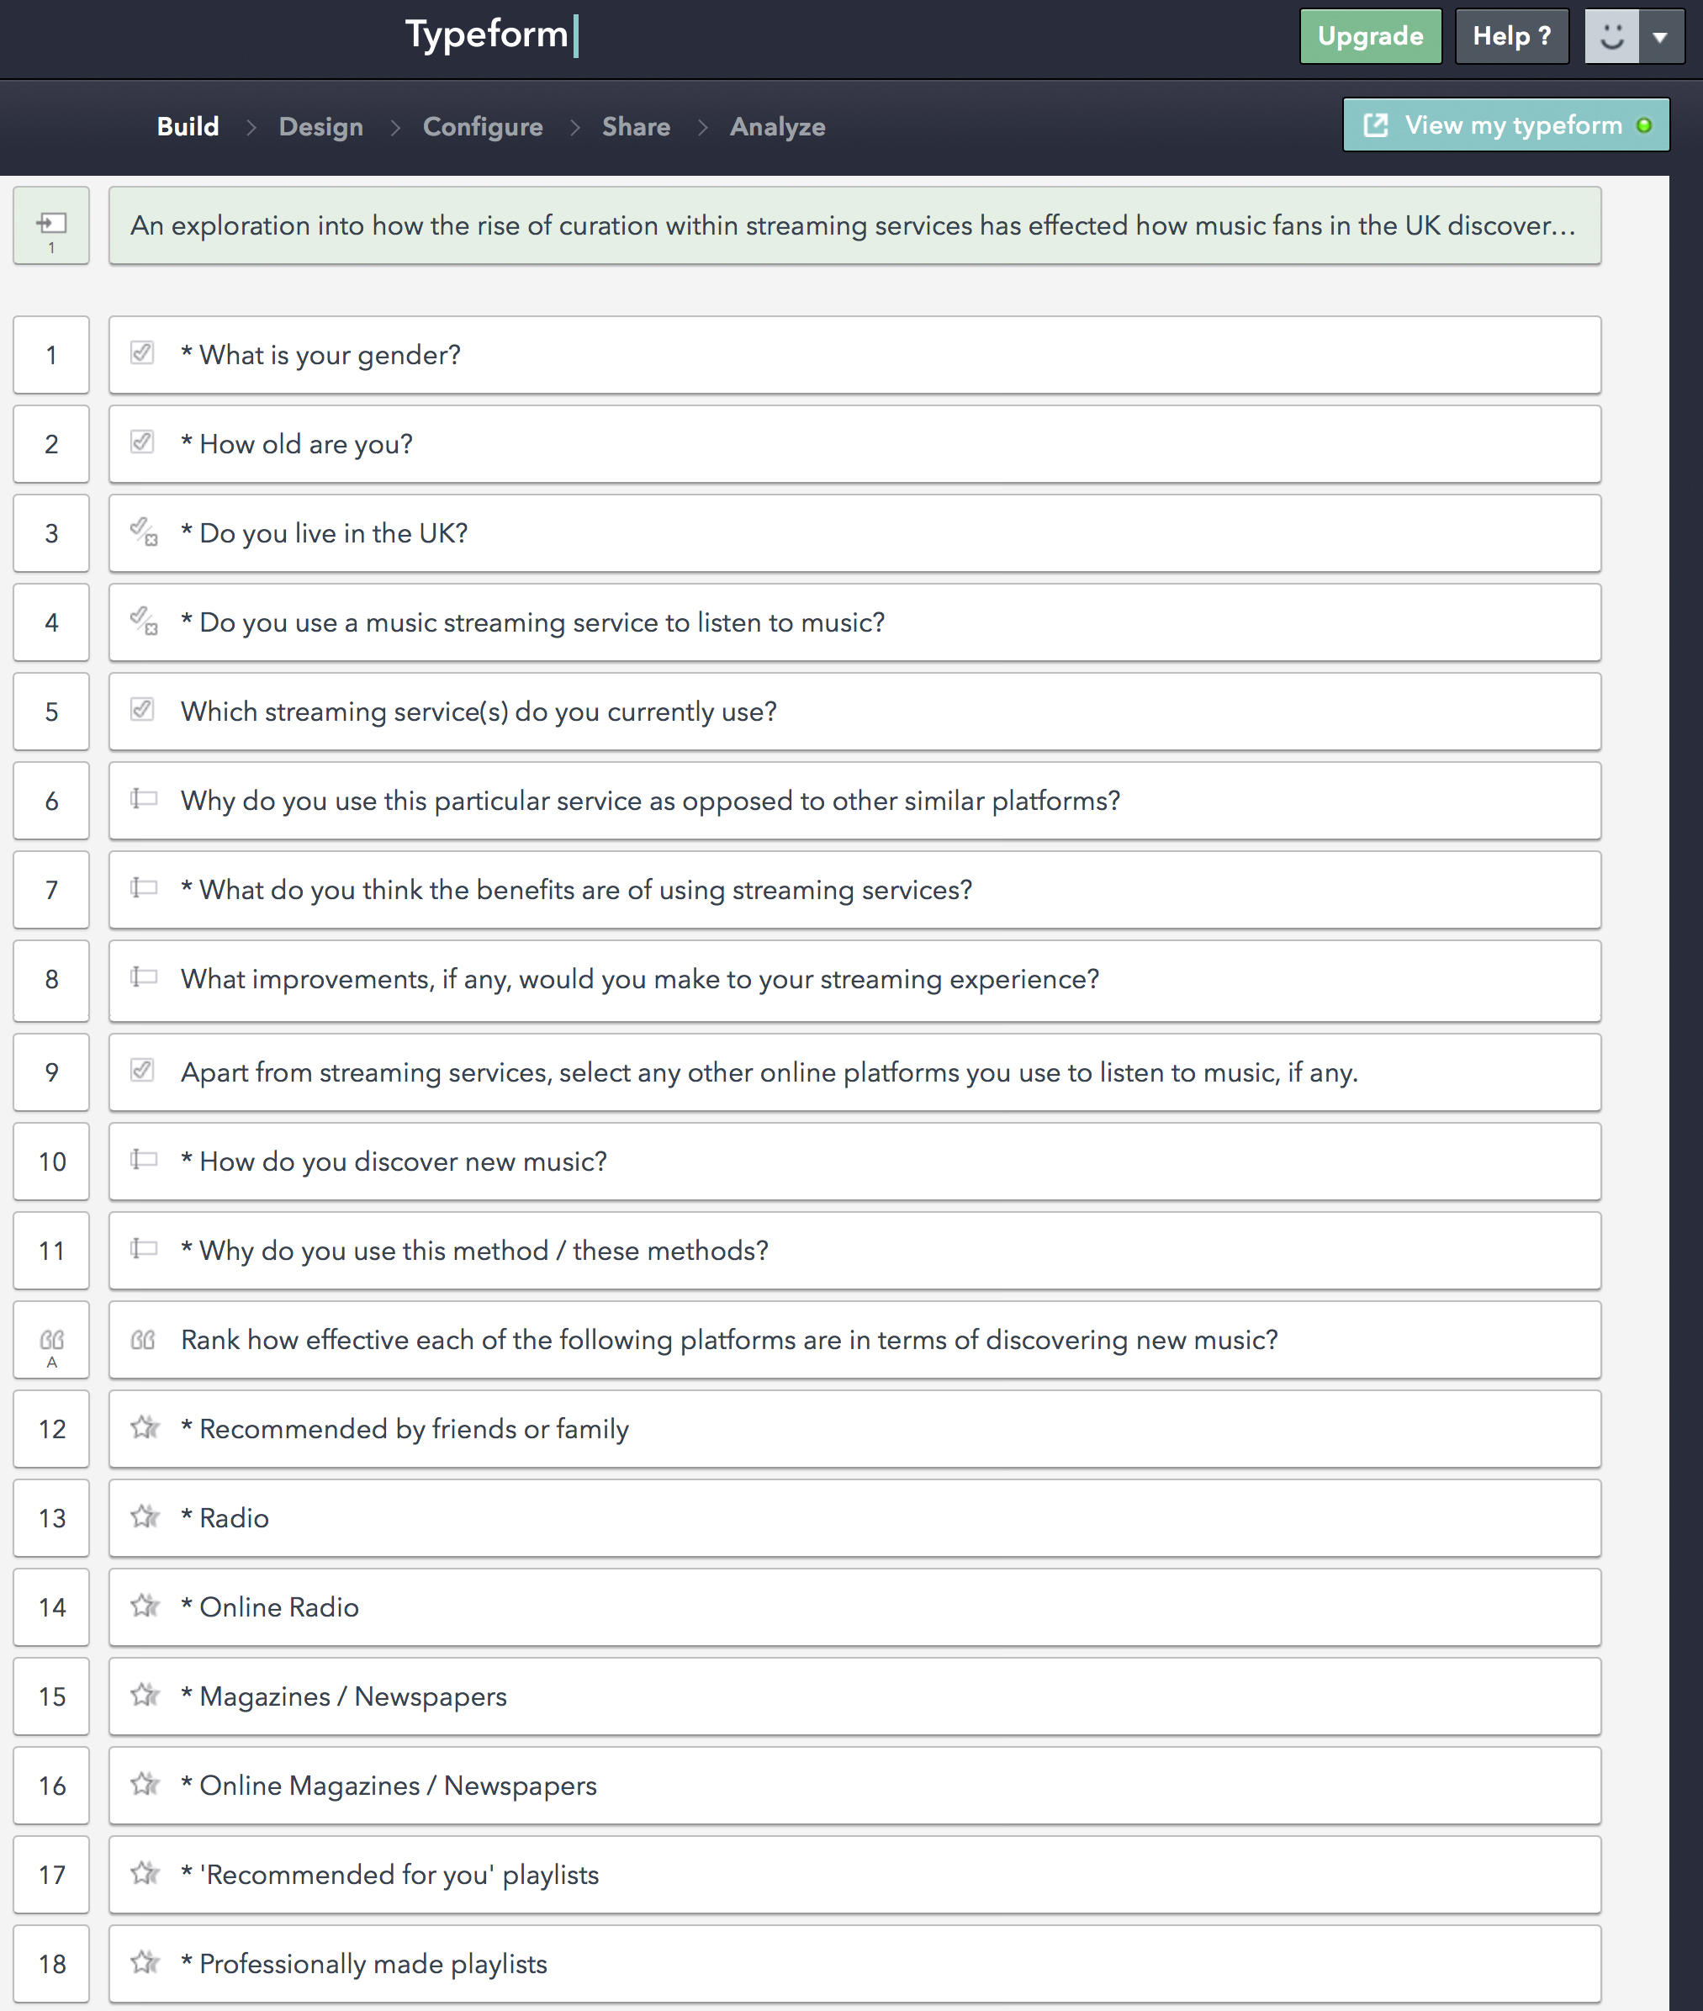

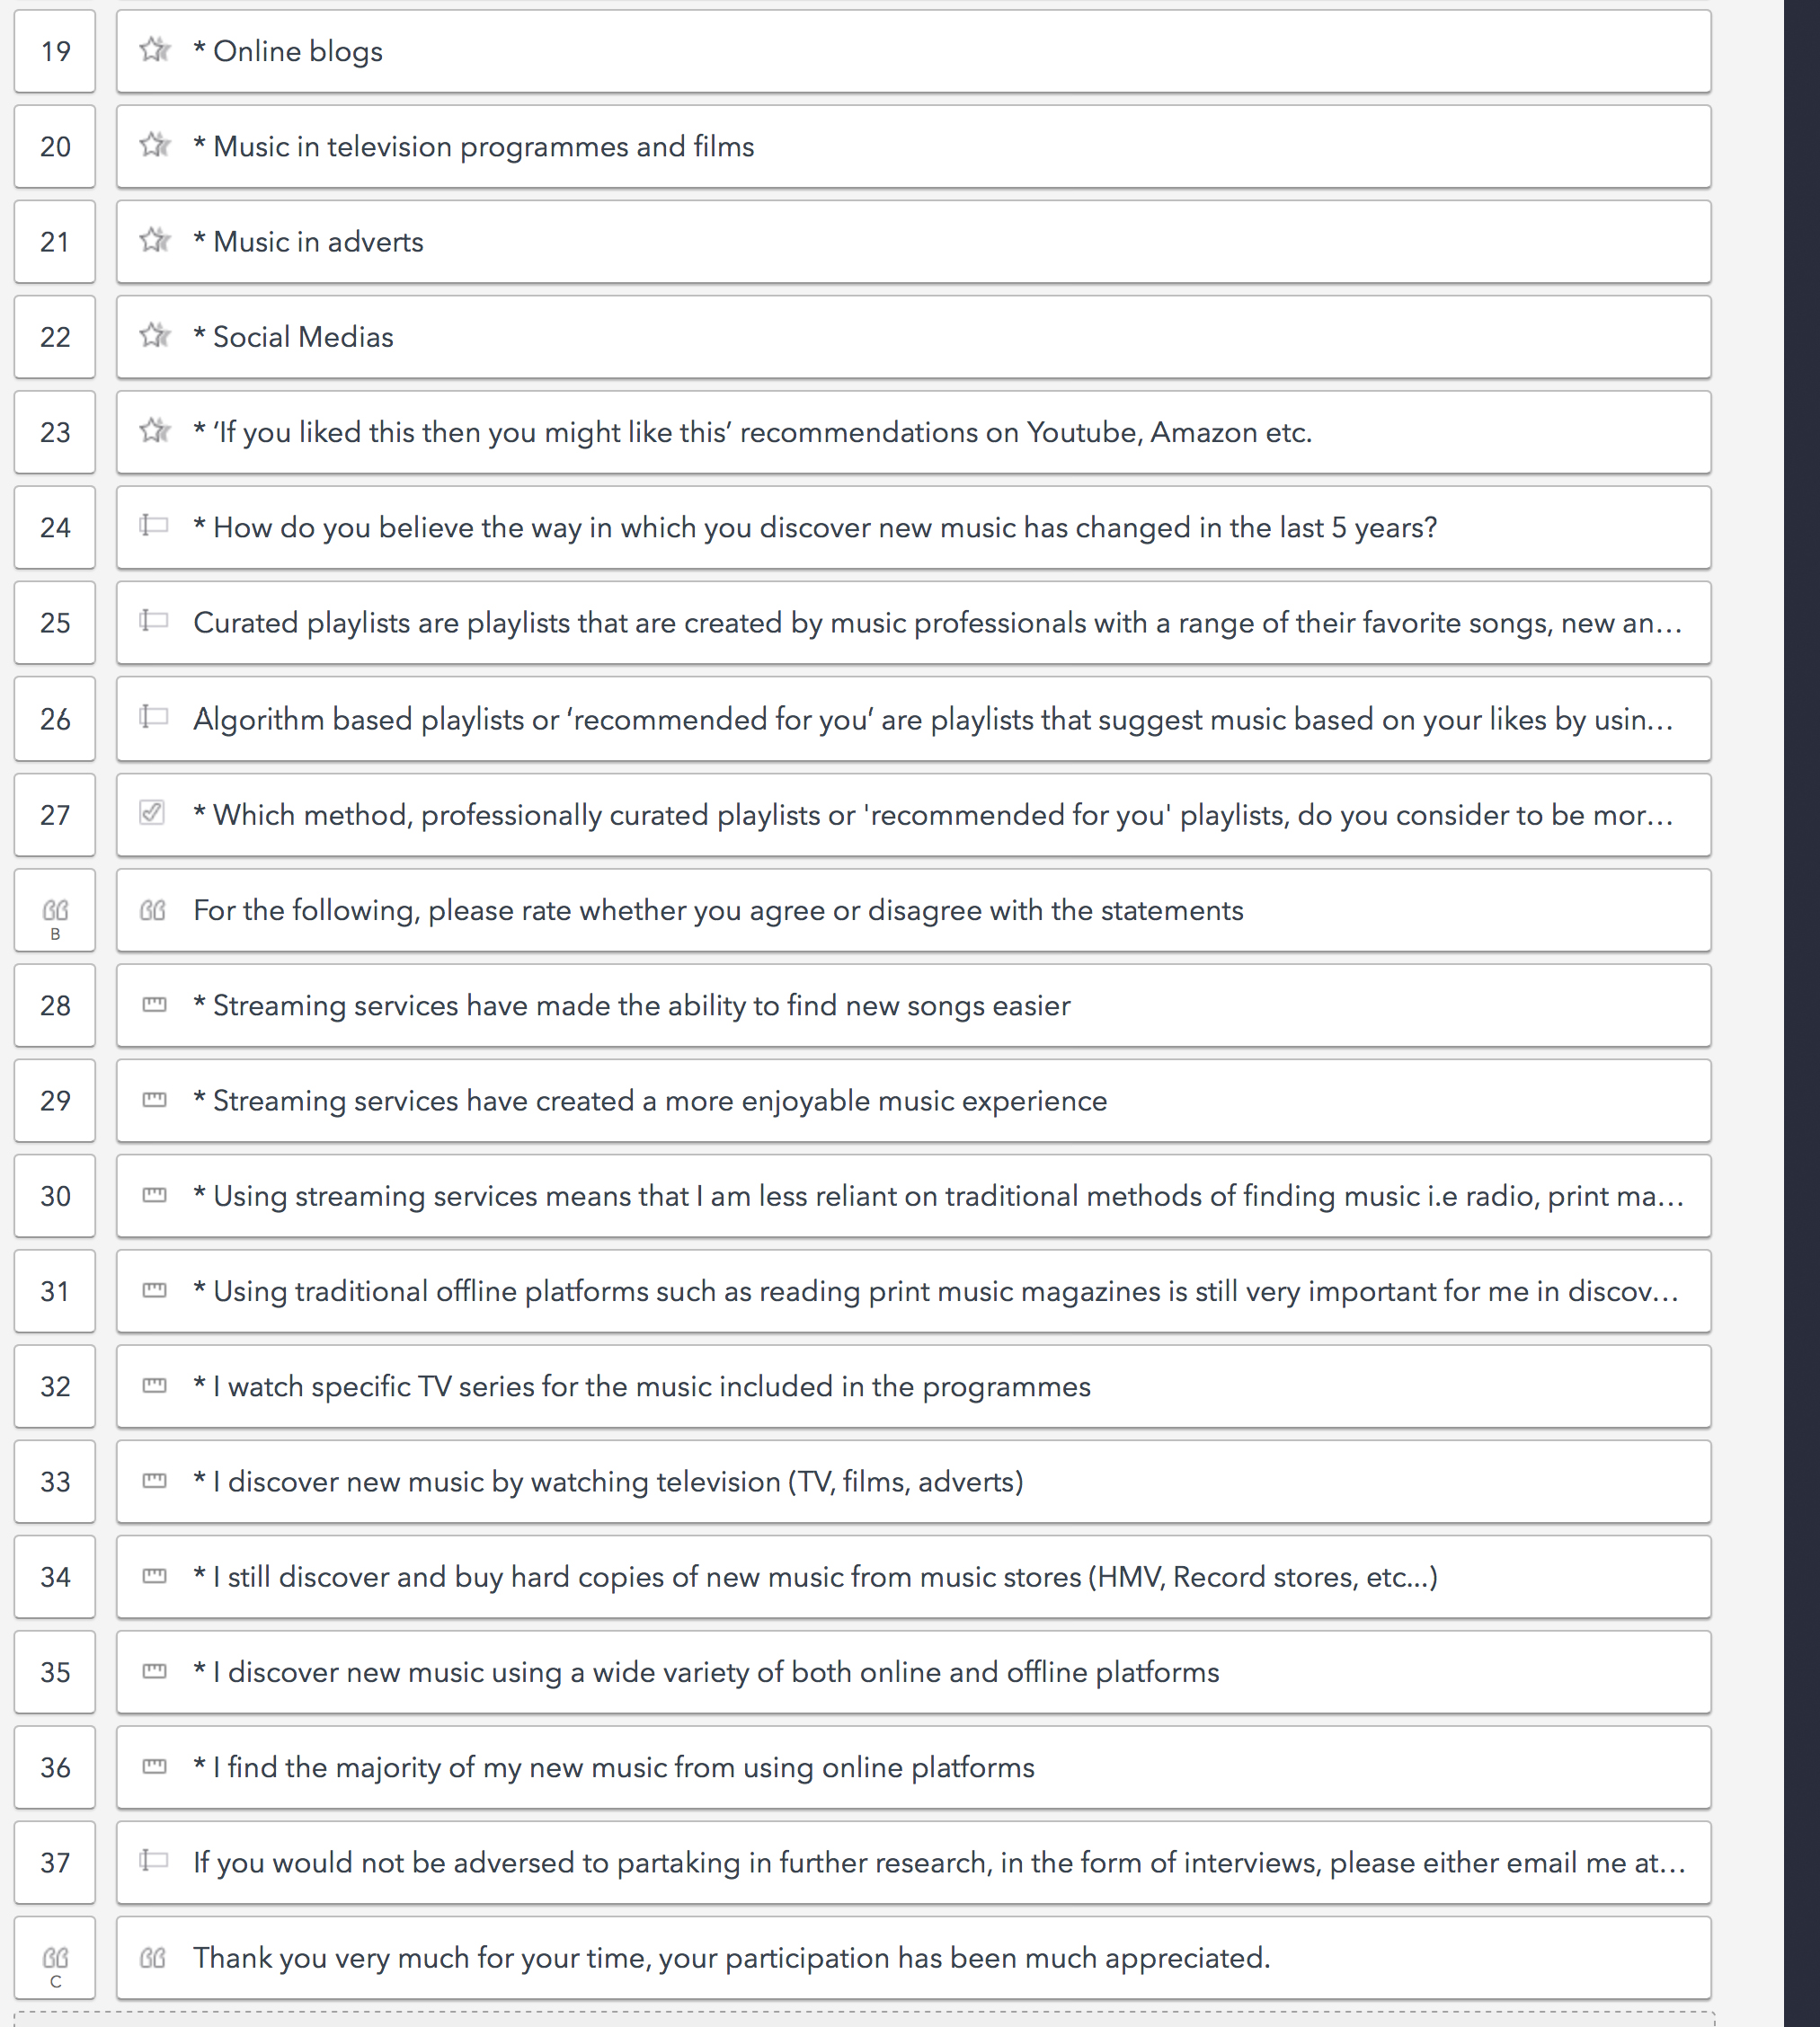

* 1. Appendix 2- Participant diaries

**PARTICIPANT INTERVIEW DIARY**

As well as contributing to my research, this diary will serve as a prompt for your interviews that will take place next week. The diary is here to help you remember specifically when, where and on what platforms you listened to music throughout your week. Thank you for your participation, if you have any questions please feel free to email me at [i7756402@bournemouth.ac.uk](mailto:i7756402@bournemouth.ac.uk).

Name: [Rachel]

Date of birth: 21/03/94

Date started: 07/04/16

|  |  |  |
| --- | --- | --- |
| **DAY 1** | Roughly how many minutes / hours of music did you listen to today? | 7-8 hours |
| What platforms have you used today to listen to music?  Radio, Television, Youtube, Streaming services etc… | Spotify |
| If you have listened to or discovered new music today, how did you do this? | Discover Weekly on Spotify |
| Was your streaming service the primary platform you listened to music on today? If not, what was. | Yes |
| If you used your streaming service today, what aspects did you use?  Listening to your own playlists, suggested playlists, radio, discover weekly etc… | Own Playlists, Spotify created playlists, discover weekly |
| Have you listened to more music on online or offline platforms today? | Online |

|  |  |  |
| --- | --- | --- |
| **DAY 2** | Roughly how many minutes / hours of music did you listen to today? | 8-9 hours |
| What platforms have you used today to listen to music?  Radio, Television, Youtube, Streaming services etc… | Radio, Spotify |
| If you have listened to or discovered new music today, how did you do this? | N/A |
| Was your streaming service the primary platform you listened to music on today? If not, what was. | Yes |
| If you used your streaming service today, what aspects did you use?  Listening to your own playlists, suggested playlists, radio, discover weekly etc… | Listened to my own playlist and a Spotify created playlist |
| Have you listened to more music on online or offline platforms today? | Online |

|  |  |  |
| --- | --- | --- |
| **DAY 3** | Roughly how many minutes / hours of music did you listen to today? | 4-5 hours |
| What platforms have you used today to listen to music?  Radio, Television, Youtube, Streaming services etc… | Spotify, YouTube |
| If you have listened to or discovered new music today, how did you do this? | Youtube- found a song on there I couldn’t get on Spotify |
| Was your streaming service the primary platform you listened to music on today? If not, what was. | Yes |
| If you used your streaming service today, what aspects did you use?  Listening to your own playlists, suggested playlists, radio, discover weekly etc… | My own playlist |
| Have you listened to more music on online or offline platforms today? | Online |

|  |  |  |
| --- | --- | --- |
| **DAY 4** | Roughly how many minutes / hours of music did you listen to today? | 10 hours |
| What platforms have you used today to listen to music?  Radio, Television, Youtube, Streaming services etc… | Spotify |
| If you have listened to or discovered new music today, how did you do this? | N/A |
| Was your streaming service the primary platform you listened to music on today? If not, what was. | Yes |
| If you used your streaming service today, what aspects did you use?  Listening to your own playlists, suggested playlists, radio, discover weekly etc… | Spotify created playlists, other peoples playlists (Rolling Stone & Buzzfeed) |
| Have you listened to more music on online or offline platforms today? | Online |

|  |  |  |
| --- | --- | --- |
| **DAY 5** | Roughly how many minutes / hours of music did you listen to today? | 6-7 hours |
| What platforms have you used today to listen to music?  Radio, Television, Youtube, Streaming services etc… | Spotify |
| If you have listened to or discovered new music today, how did you do this? | Discover Weekly |
| Was your streaming service the primary platform you listened to music on today? If not, what was. | Yes |
| If you used your streaming service today, what aspects did you use?  Listening to your own playlists, suggested playlists, radio, discover weekly etc… | Discover weekly, own playlist |
| Have you listened to more music on online or offline platforms today? | Online |

|  |  |  |
| --- | --- | --- |
| **DAY 6** | Roughly how many minutes / hours of music did you listen to today? | 9 hours |
| What platforms have you used today to listen to music?  Radio, Television, Youtube, Streaming services etc… | Youtube, Spotify |
| If you have listened to or discovered new music today, how did you do this? | Youtube |
| Was your streaming service the primary platform you listened to music on today? If not, what was. | No, was a concentration and focus channel on Youtube |
| If you used your streaming service today, what aspects did you use?  Listening to your own playlists, suggested playlists, radio, discover weekly etc… | My own playlists |
| Have you listened to more music on online or offline platforms today? | Offline |

|  |  |  |
| --- | --- | --- |
| **DAY 7** | Roughly how many minutes / hours of music did you listen to today? | 7-8 hours |
| What platforms have you used today to listen to music?  Radio, Television, Youtube, Streaming services etc… | Spotify |
| If you have listened to or discovered new music today, how did you do this? | N/A |
| Was your streaming service the primary platform you listened to music on today? If not, what was. | Yes |
| If you used your streaming service today, what aspects did you use?  Listening to your own playlists, suggested playlists, radio, discover weekly etc… | My own playlists, Spotify created playlists, user created playlists on Spotify |
| Have you listened to more music on online or offline platforms today? | Online |

* 1. Appendix 3- Participant 1 interview transcription

**PARTICIPANT 1 INTERVIEW**

**Welcome, thank you very much for participating in this interview. I’d just like to start with a few questions about yourself, what is your name?**

[Gregory]

**How old are you?**

19 years old

**Where about do you live?**

London

**How long have you been a music fan, or been passionate about music for?**

Probably really for the last four or five years

**Why do you listen to music?**

I listen to music when I’m basically doing any activity; it keeps me happy, it keeps me distracted if I’m at the gym, it keeps me motivated and it can really change my mood

**Would you say music then is quite an important part of your life?**

Yeah I would say it is definitely something that I either listen to or try and find new music every day so it is a very important part of my life

**How much time on average would you say you spend listening to music?**

Daily I would say 1-2 hours.

**How much time in relation do you spend discovering music?**

About half an hour every other day I would say, quite a lot. I like to keep up to date with what’s going to be the new trends in music and artists that I might not discover if I just listened to the radio

**Is discovering music quite important to you then?**

Yeah it keeps me relevant I think, I like to know what the good songs and big tunes are going to be before they reach the masses, to coin a phrase

**You use a streaming service yes?**

Yes I use apple music to stream most of my music

**Do you remember when and why you first started using streaming services?**

When Apple music was released, I didn’t want to use Spotify or any of the other ones because I already had an existing I tunes library and I had a lot of music on there so I didn’t know how or if I could link the two together. But when apple released Apple music it seemed very easy to press a few clicks and it already linked to my iTunes account and then I could just get going from there

**It was quite an easy thing to get into then?**

Yeah, very easy

**How long have you used this service?**

About 7 to 8 months, actually less than that about 6 months maybe

**How often do you use this service, is it something that you use everyday?**

Yeah this is the main way that I listen to music, so I listen to it everyday

**Why Apple Music specifically, are there any benefits it has opposed to other services?**

Its very easy to use, it links with all my pre existing I-tunes library, it allows me to sync my music very effortlessly from my computer to my phone and other devices and its cheap as well, its like 13 dollars a month or 10 pounds or something and I trust Apple as well

**Are there any perceived weaknesses that you see?**

Its still very new so it currently has some flaws, maybe it could be fasted at syncing, use less mobile data when I’m trying to stream music from my phone something like that

**What are the benefits of streaming services in general?**

I think in the whole you spend a lot less money than buy buying hundred and hundreds of songs and you also get to listen to a really wide variety of music, if I want to listen to something I don’t have to download it and pay for it, I can just type it is and pretty much every song released on record is there at the tip of my fingers

**Apart from Apple music do you use any other online or offline platforms to listen to music? Youtube, Soundcloud etc?**

Yes I listen to blogs such as Indie Shuffle and GRM daily as well as watching their Youtube channels and I follow a lot of artists on Soundcloud but I don’t check that as frequently. I check blogs for new music that are curated by professionals most days

**How much of your music discovery would you say is done on apple music?**

Probably about 40-50%, when I first started I would say that I probably only used it for about 10% but now I have added more of my likes and it knows me better I can use the recommended thing and it shows a lot of playlists but I do actually find songs that I do like from this

**What would you say your top three methods of discovering new music are?**

By blogs, the blogs I use are Indie Shuffle, Pigeons and Planes and also GRM daily

**And these are all people suggesting their new favourite songs?**

Yeah it’s a group of people who are very into music and love music basically, they trawl the Internet and it’s like a community listening site, quite social

**What are the other two?**

I like Apple music because it lets me find loads of things from the database and I can pretty much listen to it instantly and its also very easy to quickly add songs to your playlists, they’re instantly there and you don’t have to download them or anything you can just add them to your playlists, very simple. I like Soundcloud as well because it’s like a chronological timeline, so I can what songs are new and what has just been released which is really good

**‘Suggestions by friends and family’ and Radio were two other leading methods, do you feel these play a part in your personal discovery?**

Yeah I think that friends do play a large part in my music discovery, if I get into a conversation with a friend about music and they say you have to listen to this song or this artist I will because I trust their opinion and its very likely that I will go home and listen to that song

**Does Radio play a part as well?**

It does but I think a lot of the songs that you hear on the radio are the songs that you’ll hear pretty much everywhere. Those are the songs that will find you no matter what you do, every club that you go to, restaurants, other places, they all play music and it will be the songs that they play on the radio. I think it does play a part but more subconsciously

**How do you feel that your music discovery methods have changed in the last 5 years?**

In the last 5 years, I would more purely rely on what everyone else was saying when I was at school, so word of mouth meant a lot more to me then it does now and also I did used to listen to a lot of radio for all of those chart hits so I think my method of discovery has changed as my tastes have changed

**You use a lot of online methods, apart from these methods, are there any traditional methods of discovery that you use? Do TV or magazines for example play a role?**

I would say TV plays a bigger role than magazines, magazines like NME have never inspired me once to buy a song purely because of the fact that you’re not listening to the music, you cant hear any of the music you can just read what they’re describing to you. I think its kind of useless to be blunt. With TV I am much more likely or inclined to discover music, if I hear a song in the show that I like then I will get out Shazam, so its not really shows that are telling me what to listen to, I’ll be watching and then subconsciously something might jump out at me and I’ll Shazam it

**Do you feel then that traditional methods don’t really play that much of a role in your discovery?**

I think they used to a lot more than they do today, I think today people are listening to a lot more diverse range of music thanks to the rise of the Internet, its so easy just to discover new songs rather than having to rely on traditional methods from experts or reviewers. People are forming their own opinions on what kind of music they like and then actively going out and finding it themselves rather than just relying on what everyone else is listening to or what your friends listen to

**Speculation but where do you feel the music industry will be in 5 years time?**

I think everything will go digital, CDs wont exist, (discovery) listening will be purely all streaming services so actually buying music wont be something that really goes on anymore, already on Apple Music, where I used to go on the I-tunes store once a day to buy all my music, I haven’t been on the store ever since I got Apple Music. So I think it’s definitely all going to go into streaming and also recommended playlists because the more views that steaming services get the more it gets to discover your taste so the more I will probably trust them to recommend me new songs and things

**Streaming services use a mixture of algorithms and human curated playlists. Human curated playlists are made by professionals in a certain manner to invoke feelings, etcetera. Do you use these playlists, what do you perceive the benefits to be?**

I do actually; I like to see the ones that are created by brands instead of by Apple, I find it interesting to see what kind of music represents that brand, I will take their opinions better. For example, GQ has a playlist on Apple Music called Grimiest Grime and its very well made and it has a lot of the classics on, so I’m more inclined to trust their opinion because they are a magazine and obviously they will have to research so its not just a random person that likes a bit of grime they are actually going to have to do research into the music to protect the brand name. So they’re going to have to do their research and you know that what they are suggesting is going to be well thought out and its going to be a cross section of all types of grime music instead of just an artist they like most, if that makes sense

**Are there any weaknesses that you see in these playlists?**

I think there’s a good chance that it could get overly saturated the playlist section, there could just be too many and it would get clogged up. And you don’t really know who to trust, if you were looking for a playlist and every magazine has got a different take on it and loads of different people have made playlists for different things, I think that can get clogged up very quickly and it would just be a bit of a mess really, unusable, too many cooks spoil the broth.

**On the flip side, algorithmic playlists suggest songs based on your likes, what are the benefits of these playlists?**

The fact that you can have full control over what you like and what you don’t; it only uses the things that you’ve said you like and you can unlike songs as well. So if I was really into Arcade Fire when I was younger but I didn’t like it anymore I could unlike the songs and then it would keep it up to date and relevant. I also like it because, I mean they’re not too clever but you’re very likely to like the songs so if you just put one of these playlists on at random there is a good chance that you are going to be able to sing along to at least a couple of them and have it on in the background. And it can help you find new artists that you might not have heard of before because obviously if they’re similar it is likely that you will like them

**Do you see any limitations or weaknesses with these playlists?**

Yeah I think its like a double edged sword because the fact that you have to manually select songs that you like as well means that if I found a new artist that I like but they haven’t released their album yet or they haven’t got them on I-tunes or I cant find them it means that I cant get suggestions based on them. And it also doesn’t know what mood I’m in so if I’m just trying to relax but it knows that I like a bit of heavy metal or hip hop here and there its just going to feel that they really don’t understand that I just want to chill out and you’re just bombarding like Wiley into my earphones

**Do these playlists play a big part of your streaming experience?**

About 10/15% and its usually when I’m bored or for a distraction. I will only listen to them in times where I am looking for new music, I like to have music that I’ve already heard on if I’m chilling or something, if I’m doing an activity I want songs that I know already and not random ones where there’s like a 50% chance that I will like them

**So it’s more for discovering you would say then?**

Yeah I think they are more for discovering

**So to conclude, for you personally which do you perceive to be more effective way to discover music in Apple Music, human or algorithmic playlists?**

I would say the human curated playlists because I don’t think the algorithms have as much information as they need yet, and with the human curated playlists I think you are more likely to trust a brand or an actual person than you would an algorithm, so its more like word of mouth, it’s like the modern word of mouth

* 1. Appendix 4- Participant 2 interview transcription and coding

|  |  |
| --- | --- |
| **Coding schedule** | |
| **Objectives** | **Themes** |
| 1. Streaming services | Price |
|  | Ease / accessibility |
|  | Control |
| 2. Discovering techniques | Traditional methods (Radio, WOM, TV, Magazines) |
|  | Online methods (Social media, Blogs, YouTube) |
|  | Streaming services (Algorithmic, Human Curation) |
| 3/4. Human and Algorithmic curation | Reliability / Trustworthiness |
|  | Efficiency |
|  | Social / Personalisation |

**PARTICIPANT 2 INTERVIEW**

**Welcome, thank you very much for participating in this interview, it is much appreciated. I’d just like to start with a few questions about yourself, what is your name?**

[Rachel]

**How old are you?**

I’m 22

**Where about do you live?**

I am from Leister

**How long have you been a music fan, or been passionate about music for?**

I would say that I really first got into music when I was about 12, 13; I dance and have done since I was like 3 and so its always been one of those things where, when we got a bit older, one of the things we could do with dancing was pick your own songs to dance to, so that sort of started it off, then all my friends got into it

**How important is music to you? Why do you listen to it?**

For a million different reasons; it puts me in a better mood, as background music for a lot of the time and usually I like to have specific songs that I just want to listen to because they’re my favourite songs, or they remind me of stuff, loads of different reasons

**How much music would you say you listened to on average, daily, weekly?**

It depends; I think I go through phases with it, at the moment its constant because I’m working so I’m listening to it about 8 or 9 hours a day, literally all day. But also I’ll go through phases where I don’t want to listen to it, or I just want to listen to the radio as there’s nothing that I’m particularly interested in at that moment, so I’ll be watching more TV etc, I probably listen to it for a reason so if I’m travelling somewhere or I’m doing something and I want background music

**How much time would you say you spend actually discovering new music?**

Again it depends; sometimes I will have days, I don’t know whether I’m procrastinating or whether I’m just sick of listening to everything that I’ve got, where I’ll spend a good hour going through new stuff. But on other days I just don’t want to choose. I’d say I spend a couple of hours every few weeks making a conscious effort to find new songs.

**Would you say it sort of comes in stages?**

Yeah I will have a few new songs, and what I’ll do is, if something comes up on twitter or somewhere, I’m quite big on different music suggestions from pages, like Rolling Stone is good for it where they will create a playlist which is like ‘these are the songs you need to be listening to now’ and I will listen to that and I’ll take the ones I like and I will put them into a playlist; I’ll go through different ones and put them into a playlist and it either grows from there or delete the ones I don’t like and then I get a bit bored of those ones and move on

**How important would you say discovering new music is to you?**

Yeah pretty important I think; I think its one of those things where it was much more important to me when I was younger. When I was about 16/17 I was obsessed with knowing the latest and being the first. I remember when Alt-J had just come out, I had heard them about a year before, I’d heard a couple of their singles and then everyone else started to listen to them and I was like I had them so much earlier before everyone else, I’ve heard these songs now everyone really likes them. So it was much more important back then and now its nicer to just hear what is out there, what’s new and where things are going and just about having a wide range of things to listen to, its always nice having songs that are new. It’s less about proving to other people now though

**So you use a streaming service?**

Yes, Spotify

**Do you remember when and why you first started using Spotify?**

Yeah, so my ex boyfriend who I was with at school was talking about it and I didn’t know what it was, and he said that I needed to get it and asked ‘how do you hear music? What do you do?’ So I ended up getting it but I didn’t really understand it at first, I got the free version, I think it was actually only free then, and I had no idea how to use it so I was just going on and finding weird songs from artists that I vaguely remembered and following some people but I wasn’t really using it very well. And later some sort of advert for it popped up and I ended up going back onto it and thinking hang on a minute this is alright! Then I remember in first year of uni, so about four years ago now, I think I hadn’t used it for a while and then I ended up going on there because I got an email saying they had an album that I really wanted to listen to on Spotify and then I went on listened to it and went from there. And that was when I had the free one and you used to be able to mute the adverts and it wouldn’t play so you could get away with not listening to them but gradually I got more invested in and now I pay 5 pound a month for the service

**So you are on the paid subscription?**

Yeah and its completely worth it for the amount I use it

**And you would say that you’ve probably used it for about 4 or 5 years?**

Yeah on and off about 5 or 6

**How often do you use Spotify; daily, weekly?**

Daily

**Why would you say you use Spotify, what are the benefits over other services?**

I am not as familiar with other services, I know a couple of people that use Deezer but its only on your phone and what I really like about Spotify is, its similar to Apple products in the way that they are trying to understand how people listen to music and adapt. As I have been using Spotify its gradually got better, so if I have music on my phone then I can control speakers on my laptop. Little things like that, and the playlists, particularly discover, the constant stream of new music. And I think the amount of content they have on there as well. There are a couple of people that they don’t have, Prince for example. That really bothers me because they used to but now they’ve got rid of [his music] and now they only have his brand new stuff, which is okay but other than that I feel they do pretty much everything.

**Are there any weaknesses you perceive Spotify to have?**

I think that the way the dashboard works on the left hand side really bothers me, I want to be able to organise everything I have by artist. I’d love to have my playlists and then all of my saved songs as a playlist that I can organise by artists. Everyone I have spoken to regarding playlists feels really unorganised about it and I think that organisation is such a nice thing to have with your music. And I think it could update a bit more regularly, I know they are updating a lot but I’ve experienced it where I’ve gone through new releases before and it will be a really good day for new releases but when I go back a week later they are still the same ones. I think that may be a bit demanding though (laughs)

**In general what do you think the benefits of streaming services are?**

The amount of music that is available, the flexibility of it in terms of I can listen to anything I want when I have Wi-Fi but also I can save songs offline; so last year when I commuted I used the tube a lot and I would save songs/playlists. Even in the morning I would know what song I wanted to listen to, say I wanted to listen to an album I would make it available offline when I was at home getting ready and then I could listen to it. There’s no other service I know, apart from iTunes (which I find a bit clunky) that can do that.

**Apart from Spotify do you use any other online, or offline platforms or websites, to listen to music on?**

I use Youtube a bit, just for stuff that is not available on Spotify or sometimes if I want to watch a music video or something like that; it’s nice to have a look at different bits and pieces. It’s one of those things where I’ll go on for one specific reason then end up on there for an hour. And I used to listen to Soundcloud a bit but it kind of gets on my nerves because it doesn’t feel like it’s moved on or progressed much; it’s just a website and I always end up accidentally closing it. I-tunes I used but the thing I don’t like about i-tunes is that its just so inflexible, I downloaded a Beyoncé album two years ago and I don’t want it on my phone anymore but I don’t know how to delete it, its just stuck there. I don’t really understand how I-tunes works anymore, I used to when I was younger but it feels quite restricted and I don’t use my i-pod anymore.

**How much of your actual music discovery is done on Spotify?**

About 3/4s (75%) of my discovery is done through Spotify, a lot of my other discovery is done through social media, other peoples recommendations, I have a couple of good friends in terms of that and I go to, but I used to be better at going to live music, I make an effort to look up supporting acts and go to festivals, I’ve done Glastonbury for the last few years and I always try and go to a stage like BBC introducing. I think because I actively make an effort to do these things, Spotify takes a lot of the job out of it for you, so that’s where the majority of my discovery comes from, but I also actively search for music.

**You alluded to some there but what would you say your top 3 methods of discovery are?**

So Spotify would be the most, just because I think they have got a lot better at the recommended for you, and their patterns are getting better, so if I am listening to old songs they will recommend similar older songs like it that you are in the mood for which I think is really clever. Twitter articles, not really Facebook, mainly Twitter, I follow a lot of music magazines but completely online, I don’t buy them, and I dislike NME but like Q, Rolling Stone. All completely online though, I will end up scrolling through Rolling stone and they make a lot of good recommendations. And then other ways that I discover music… recommendations through people I know; you hear new music on the Radio as well, yeah Radio would be one for me, 6 music do quite a lot of good stuff, it’s a bit older but it’s a bit different. I do like Radio 1 but its just a bit repetitive, if I’ve got a long car journey I will stick radio 1 one and its nice to make notes of who to listen to

**How would you say your music discovering methods have changed in the last 5 years?**

I would say I’m a lot less obsessive about it, it used to be a lot more important that the songs I was listening to were new and discovered by me, whereas now I do like an audition process where if I am in the right mood for it I will listen to a load of new songs and then star the ones I like and put them in a playlist. Whereas before I would have just taken the whole playlist and be like these are all of my new songs when I hadn’t even listened to most of them properly, they were just new. Now I am much more thorough with my findings but I also don’t have to tell other people what I am listening to straight away, its whatever I am in the mood for

**Do traditional methods play a role still in your music discovery? TV, print magazines?**

My parents actually watch so many music videos on music channels; they’re into watching sport but on evenings when nothing is on sport-wise they will just listen to music channels and they watch older programmes such as ‘guess the year’. I have a bit of knowledge in terms of that, I watch TV when I am at home but I wouldn’t watch current music videos, I don’t really get that. CDs I buy for my mum a lot, I wouldn’t say I buy physical CDs very often but I make them for my parents, my mum only has a CD player in her car so I like to make them for her.

**Do you feel that you’ve moved more away from traditional methods then, its more focused on online?**

Yeah definitely, even my I-pod, I got my first i-pod when I was about 15/16 and it was like my life. I wouldn’t go anywhere without it, it had all of my music on there and it was so organised and now, for starters the i-pod doesn’t work anymore, but its so much more convenient to have it on my phone because before you had to be constantly updating, having to go onto your computer and load the songs on, download songs. Whereas streaming is just so much easier because it can be completely mood driven, you can go on to your service and think ‘this is the mood I’m in today’ and with Spotify doing specific playlists its earns itself.

**This is speculation but where do you see the industry in another 5 years time regarding streaming and discovering?**

I think streaming will become the biggest thing, but I don’t think many people currently pay for their subscriptions now, I don’t think people don’t like paying for their music at all so I think we’ll see more in terms of people crossing over to streaming services. I think they will start offering cheaper versions of streaming services, I’ve seen a couple of models where you can pay a pound a week or a three proud a month and you get a limited amount of songs. I think there will start becoming more types of streaming services and I think more people will start paying for Spotify. In terms of discovery I think the role of festivals play quite a bit part, it would be interesting to see if they managed to merge the two ideas. I think downloading music will die out, downloading music to me is the equivalent of Blu-ray, its good but the whole point of having music online is so that you can do anything with it and downloading is a bit old

**Streaming services use a mixture of human curation and algorithmic. Human playlists for example could be Annie Mac’s recommendations. What benefits do you think these playlists have?**

The human ones, I think the thing about music, music is quite personal to everyone but there is nothing better than everyone enjoying a common song and sharing things. Annie Mac is a really good example; it provides people with a chance to discover new music based on a person they trust which is really nice.Yeah it’s social in the terms of everyone in sharing something with you. One of my friends follows Alabama Shakes and she follows the lead singers playlist because she knows that she’s got really good music taste so she follows her. It is social because you can feel closer to your favourite artist if they do something like that. I think it is really good but obviously it depends on their taste

**Limitations?**

It depends on their taste. And this is my thing with radio DJs and when they rave about songs. There are certain people where I feel they will just rave about a song because they have been told to. When I was a bit younger I really liked Fearne Cotton because I felt like she actually picked her track of the day whereas now Radio 1 have the same track of the day the whole time. Its almost picked for them, they’ll rave about the song because they have the artist coming on so I wonder sometimes when you see a DJ that will do a playlist if they’re getting paid for it or if its sponsored. I guess it’s fair enough as it is a revenue income which is difficult in the industry but it takes something out of it because I would rather hear them share their actual music recommendations and believe that it is a great song

**Do you feel that these playlists are a big part of your streaming experience?**

Not really, the human curated playlists I like to listen to are the scenario based ones, driving playlists for example. There are not playlists created based on songs they like they are created to fit a mood or purpose. I think they’re good because they are relatable and it is a convenience having people picking out songs that can link because a lot of my playlists are just random

**On the flip side are algorithmic recommended for you playlists; what do you see the benefits of these playlists being?**

I didn’t like algorithmic at first, before they did the ‘playlist’ they used to do this thing where they would give recommended for you, you liked these artists, because you listened to x here is x. And I accidentally listened to something a bit cheesy and then it would recommend similar ones, it always used to recommend One Direction to me, and when I was a bit younger it was a real personal insult; when I was a bit more pretensions it used to really irritate me because it ‘doesn’t understand me’, its just making assumptions based on silly things like that so I used to always have it on private but it has got a lot better. I think the discover weekly is brilliant because everyone has such a wide variety of music taste, I have a friend who is into heavy rock metal and has been since he was younger but he’s also into heavy rap, and they’re real contrasts but he really likes his house music as well and I feel like he is a perfect example of music listeners today, everyone likes a bit of everything. If you speak to anyone about reggae they will say they really like it, they might only listen to a few songs or they’ve just heard one Bob Marley song. Everyone likes so many different genres and you can get into something for a week, base it on the weather, put on summer tunes. But having a weekly playlist like that is really clever I think. There is nothing better than people being aware of what mood you’re in and getting it. I think they are a really good idea, as long as they’re done well

**Do you think there are limitations then?**

Yeah I think you go in with the expectation that they call it discover weekly and they say it’s catered for you and then if you’re listening to it and thinking that fair enough and there’s a couple of songs that maybe you like. As long as you can see the thinking of the algorithm, you can see the pattern, I listened to them and x are similar, or x have collaborated with them then I think its okay. But if it’s a bit crap three weeks in a row, for example if its not very good one week then I just wont listen to it so its on them to make sure that its improving

**To conclude, which do you perceive to be the more effective method in discovering music within the service, human or algorithmic playlists?**

Algorithmic is better for discovering new music and human is better for circumstances, or mood based. With human playlists people look for things they would recognise; unless its like a DJ that I know, like Zane Lowe, or new music and bands that I know I love, I’ll go on and if he recommends something I’ll listen to it but other than that I don’t know. I’d say algorithms are better for discovering new music but human are better that you can just go on and you know what you’re going to get, its more reliable, depending on your mood, if you want something a bit safer and you know you need to enjoy music.

* 1. Appendix 5- Ethics checklist

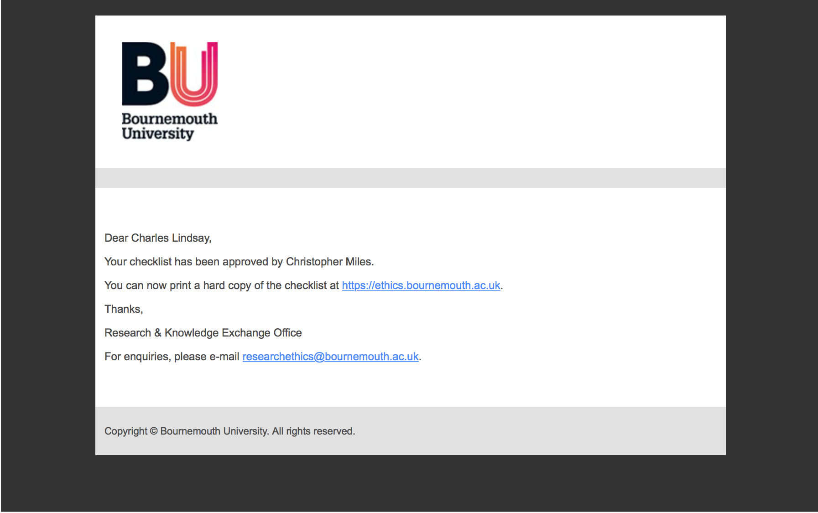

* 1. Appendix 6- Questionnaire information sheet

# 

* 1. Appendix 7- Participant information sheet



**PARTICIPANT INFORMATION SHEET**

**Research Project Title:**

An exploration into how the rise of curation within streaming services has effected how music fans in the UK discover new music?

**Name and position of researcher:**

*Charlie Lindsay*, student at Bournemouth University

**Name and position of supervisor:**

*Chris Miles*, lecturer and supervisor at Bournemouth University

*You are being invited to take part in a research project. Before you decide it is important for you to understand why the research is being done and what it will involve. Please take time to read the following information carefully and discuss it with others if you wish. Ask me if there is anything that is not clear or if you would like more information. Take time to decide whether or not you wish to take part.*

The researcher is myself, Charlie Lindsay, a final year Advertising student at Bournemouth University. My dissertation supervisor at Bournemouth University, Chris Miles, and I are the only people who will have access to the research.

**What is the purpose of the project?**

I am a final year Advertising student studying at Bournemouth University. I am interested into how the music industry operates and how audiences engage with music and so I am currently writing a dissertation to investigate the methods in which UK based music fans are discovering new music with particular regard to the role that both human and digital curation plays in the discovery process. The aim of my investigation is to understand the most effective and practiced paths to music discovery and to gain an insight into audience discovery behaviors. To gain this research I will be conducting interviews asking participants questions about their music consumption and discovery habits and why they favour certain methods over others.

**Why have I been chosen?**

You have been chosen as you are between the ages 18-35 (Generation Y), currently a UK resident and are an active music fan that regularly seeks to discover new musical content, all of which meet the sample criteria of this study. 6 participants, including yourself, shall be taking part in this study.

**Do I have to take part?**

It is completely up to you to decide whether to take partake in the in this research interview or not. If you decide to take part, you will be given this information sheet to keep and will be asked to sign a ***participant consent form***. You can still withdraw from the research up to the point where the data is processed and becomes anonymous, so your identity cannot be determined. You do not have to give a reason if you choose to decline or withdraw from the research and deciding not to partake will not impact upon you in any way.

**What will happen to me if I take part?**

If you do decide to take part in this study, you will be asked to participate in a face-to face or Skype / video call interview depending on location and accessibility; arrangements will be made to confirm a location and time for the interview prioritised around your preferences.

I will be conducting semi-structured interviews; the maximum duration for the interview will be 1 hour and the interview will be audio recorded for analysis purpose, to enable myself to transcribe and collate all ideas that come from the interview. You should answer questions honestly and if you are able to give examples this is very helpful. Please note that this recording will be deleted after the dissertation has been submitted, marked and returned and will not be available to anyone apart from my supervisor and myself.

**What are the possible risks or disadvantages of taking part in the research?**

There are no expected risks or disadvantages of taking part in this research.

**What are the possible benefits of taking part?**

Whilst there is no physical incentive, by participating in this study you will be adding to the currently limited research surrounding the paths to music discovery in the digital age as it is a relatively new topic and ever changing environment. This knowledge can subsequently be used to inform future research and findings can be used to form industry recommendations.

**Will my participation in this project be kept confidential?**

All the information collected about you during the interview will be kept strictly confidential. I will be complying with the Data Protection Act/ University policy; therefore you will not be identified in any quotations used in my dissertation. Information will be stored and kept in a password-protected file to ensure confidentiality.

**Will I be recorded, and how will the recorded media be used?**

Within the interviews I shall be using audio recording in order to transcribe findings and properly analyse my participants answers however the audio recordings of this interview will be used purely for analysis. No one other than myself and my supervisor will be allowed access to the original recordings and no other use will be made of them without your written permission; once the dissertation has been completed and marked the audio recordings and any transcripts will be destroyed. You are also given the opportunity to read your interview transcript, upon request, before the information is analysed.

**What happens if I change my mind?**

If you change your mind at any point during the study or before the study commences you have the right to withdraw at any time without giving any reason and without any consequence.

**What happens if something goes wrong?**

Should any issues arise or in the unlikely case of concern or complaint, you may contact the research governance office at Bournemouth University.

**Contact for further information**

If you need further information about this research, please contact my dissertation supervisor Chris Miles (Lecturer at Bournemouth University) via email: [cjmiles@bournemouth.ac.uk](mailto:cjmiles@bournemouth.ac.uk)

Or myself via email: [i7756402@bournemouth.ac.uk](mailto:i7756402@bournemouth.ac.uk)

Or via phone: 07827 928695

**Many thanks for taking the time to read through this information!**

* 1. Appendix 8- Participant consent form



**PARTICIPANT CONSENT FORM**

**Research Project Title:**

|  |  |
| --- | --- |
|  | **Please tick here** [✓] |
| I have read & understood the participant information sheet for the above research project |  |
| I understand that I have the opportunity to ask questions throughout |  |
| I understand that my participation is voluntary |  |
| I understand that I’m free to withdraw up to the point where the data is processed and becomes anonymous, so my identity cannot be determined |  |
| I give permission for members of the research team to have access to my anonymised responses. I understand that my name will be falsified and will not be linked with research materials, and I will not be identifiable in the outputs that result from the research |  |
| I agree to be audio recorded during the project for transcription purposes |  |
| I agree to take part in the above research project |  |

An exploration into how the rise of curation within streaming services has effected how music fans in the UK discover new music?

**Name and position of researcher:**

*Charlie Lindsay*, student at Bournemouth University

**Name and position of supervisor:**

*Chris Miles*, lecturer and supervisor at Bournemouth University

_________________ ___________ _*______________*_

**Name of Participant Date Signature**

**__**Charlie Lindsay**__ __**06/04/16_**_ __***Charlie Lindsay***__**

**Name of Researcher Date Signature**

**FIGURES**

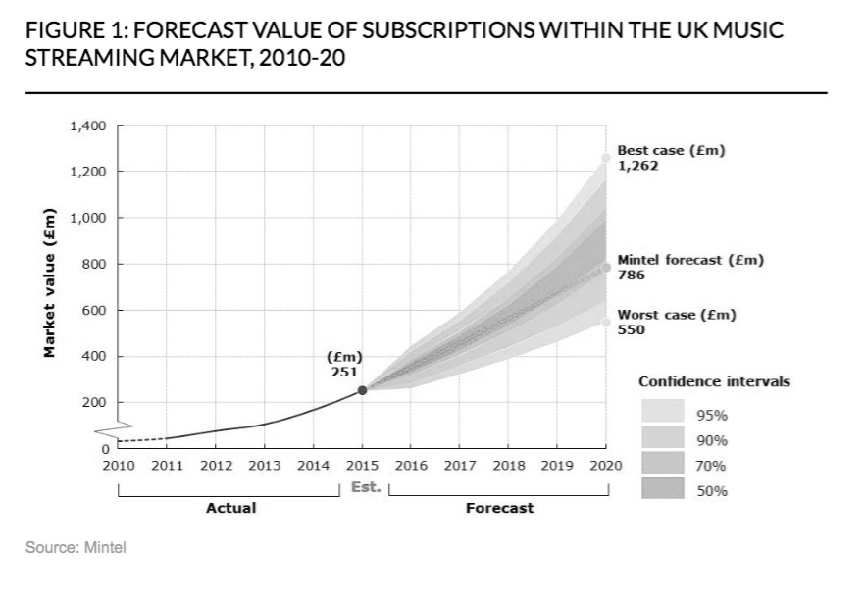

Figure 1. Forecast of UK streaming subsciption value, 2010-2020 (Mintel2016)

(2009)



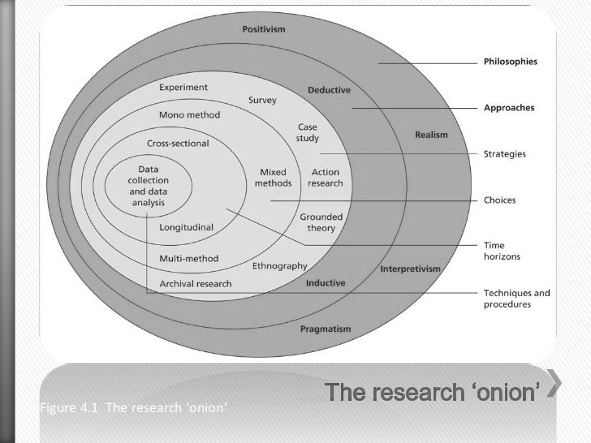

Figure 2. Saunders et al. Research Onion (2009)



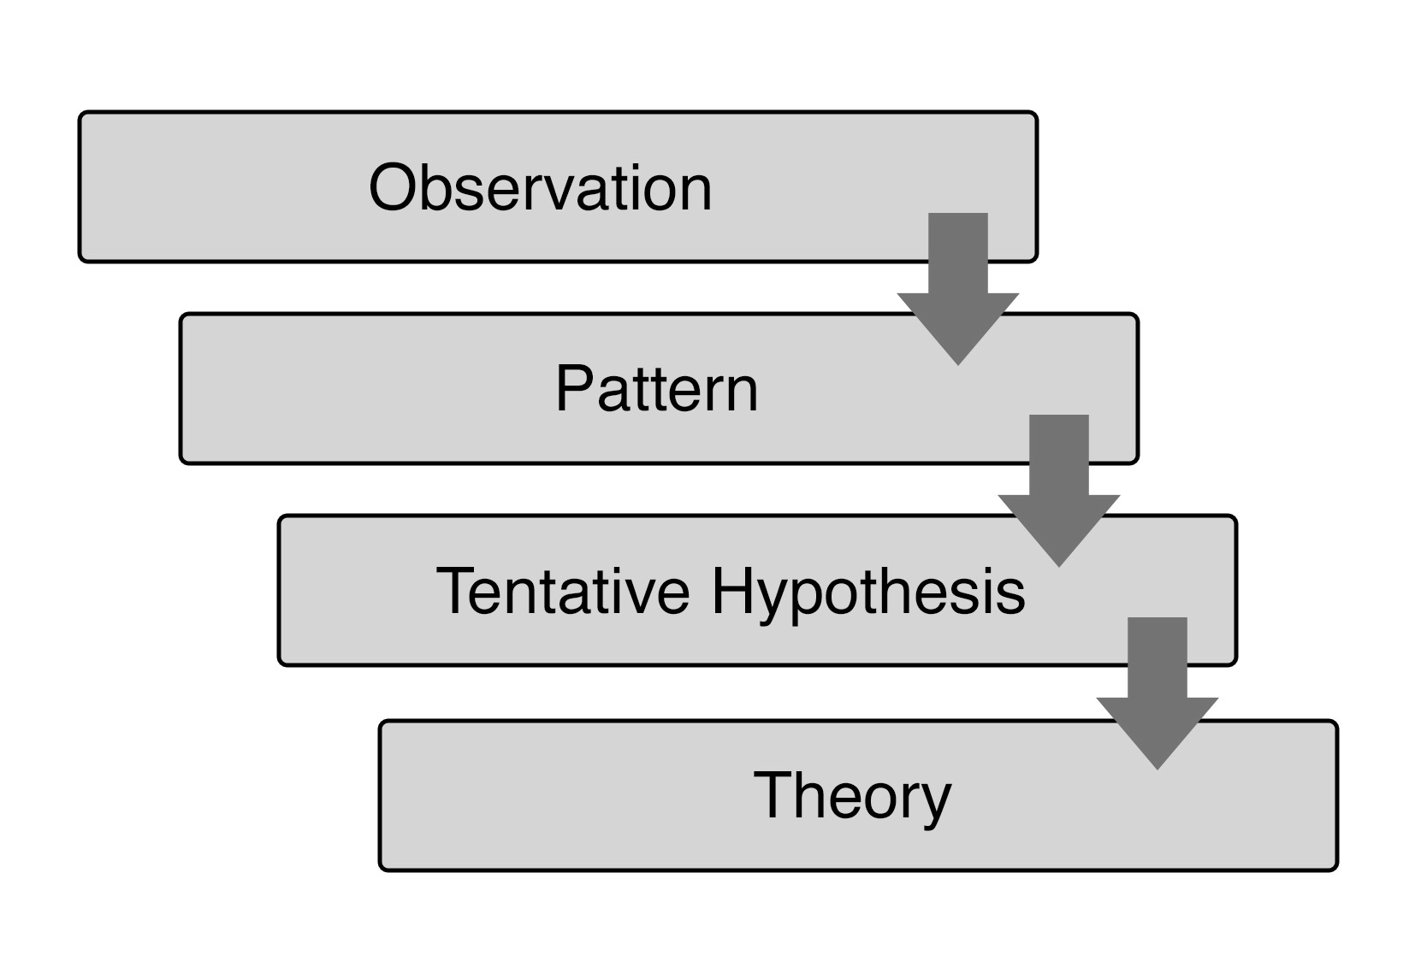

Figure 3. Inductive research approach (Saunders et al. 2009)



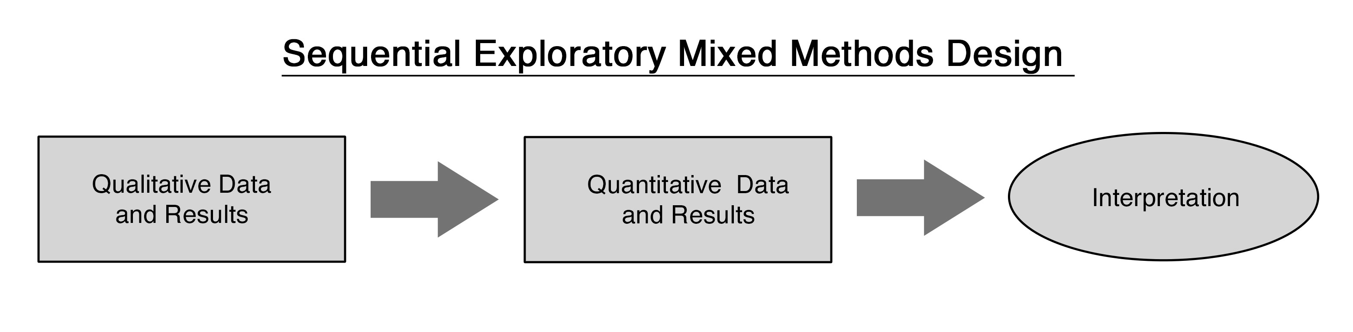

Figure 4. Sequential Exploratory Mixed Methods Design (Tashakkori and Teddlie 2003)



|  |  |  |  |
| --- | --- | --- | --- |
| **Questionnaires** | | **Interviews** | |
| Sample criteria | * 18-35 * UK resident * Music streaming service user | Sample criteria | * 18-35 * UK resident * Music streaming service user * Completed the questionnaire |
| Number of participants | 60 | Number of participants | 6 |
| Duration | Avg. 10 minutes | Duration | Avg. 25 minutes |

Figure 5. Table of research information (Author: Lindsay 2016)



|  |  |
| --- | --- |
| **Coding schedule** | |
| **Objectives** | **Themes** |
| 1. Streaming services | Price |
|  | Ease / Accessibility |
|  | Control |
| 2. Discovering techniques | Traditional methods (Radio, WOM, TV, Magazines) |
|  | Online methods (Social media, Blogs, YouTube) |
|  | Streaming services (Algorithmic, Human curation) |
| 3/4. Human and Algorithmic curation | Reliability / Trustworthiness |
|  | Efficiency |
|  | Social / Personalisation |

Figure 6. Research coding schedule (Author: Lindsay 2016)



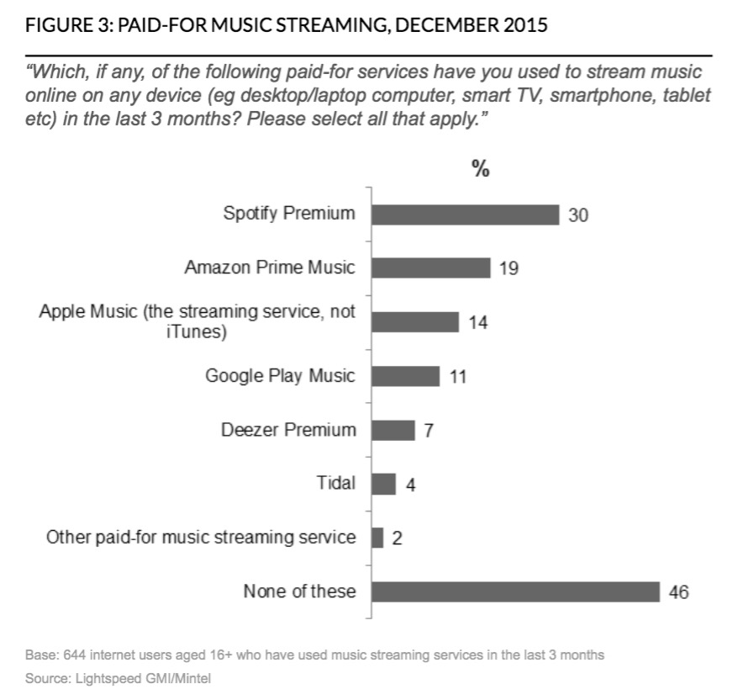

Figure 7. Leading paid-for music streaming services (Mintel 2016)



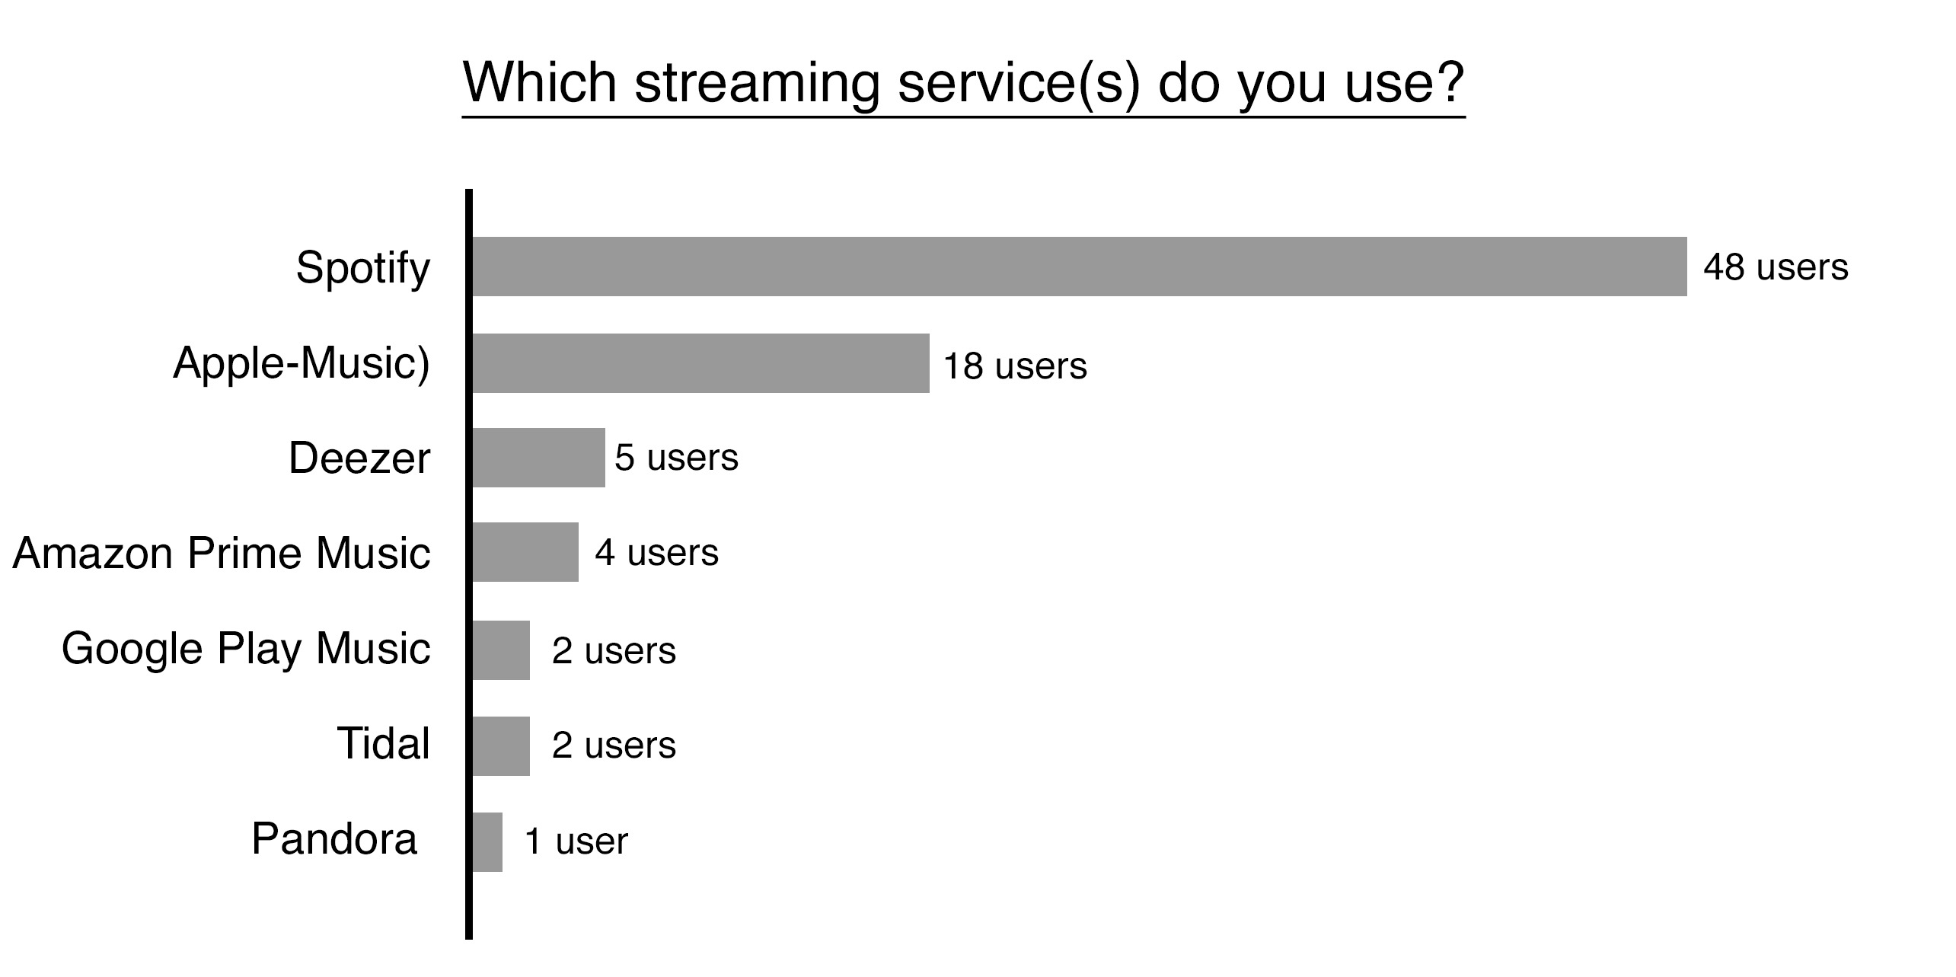

Figure 8. Questionnaire result- Which streaming service(s) do you use? (Author: Lindsay 2016)



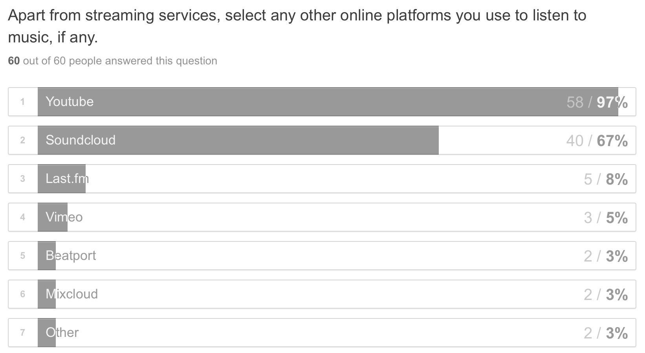

Figure 9. Questionnaire result- Which platforms do you listen to music on? (Author: Lindsay 2016)



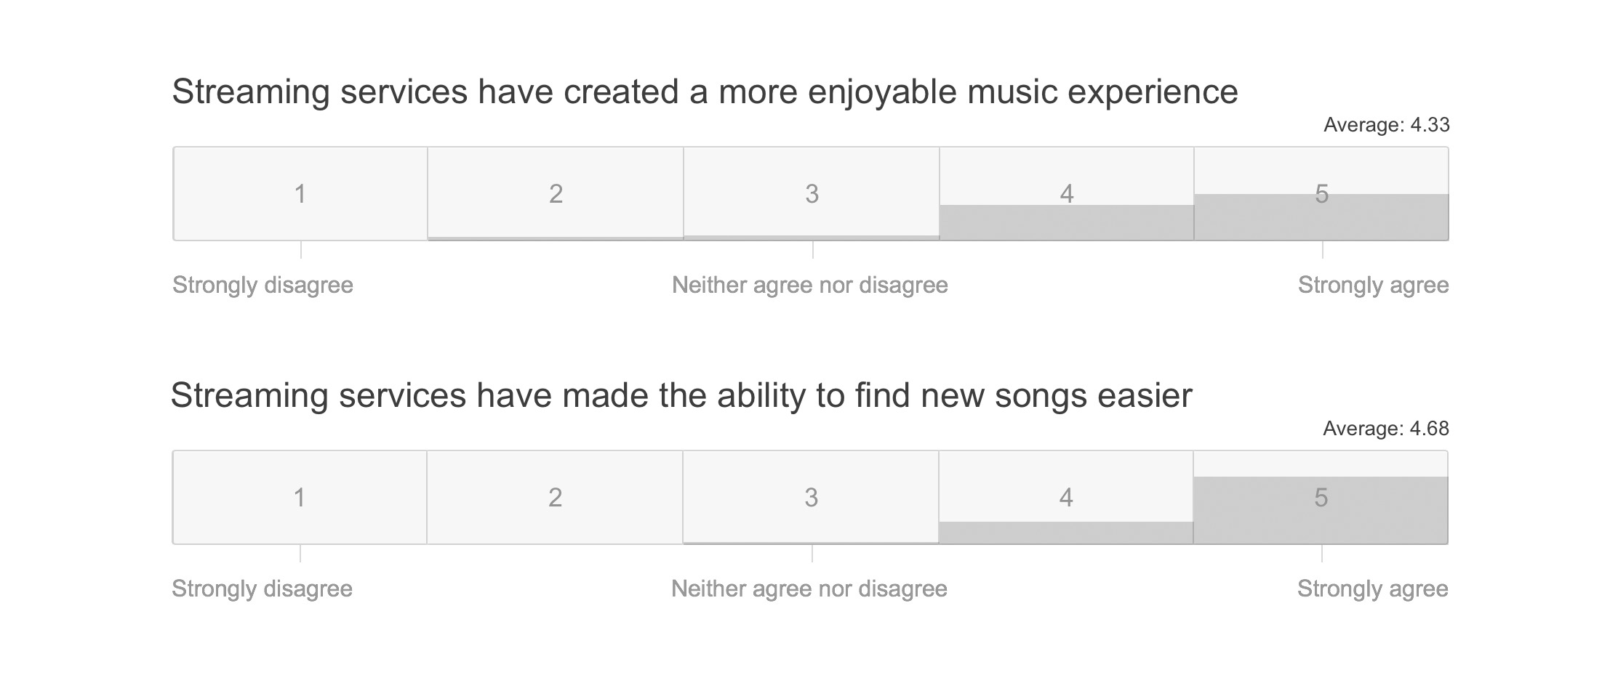

Figure 10. Questionnaire Likert scales- Streaming service perceptions (Author: Lindsay 2016)



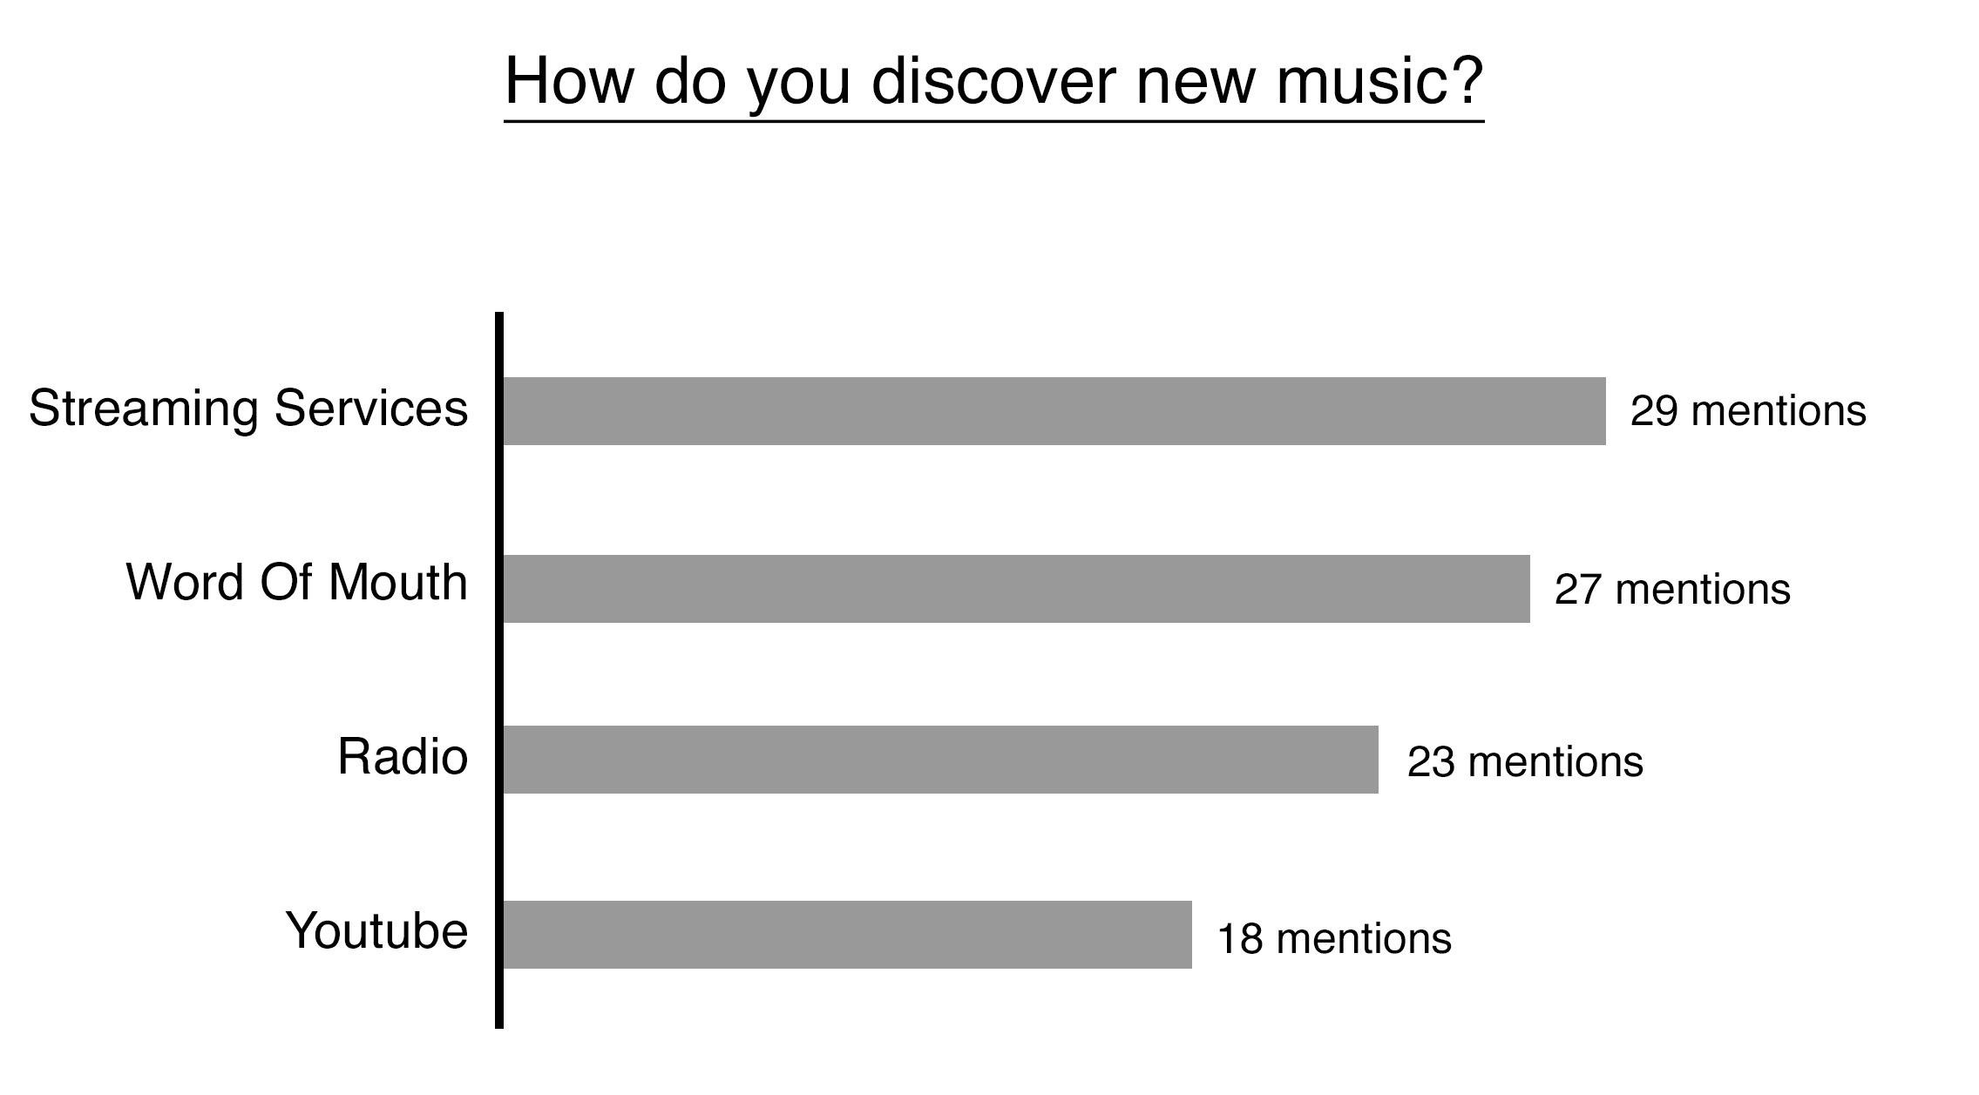

Figure 11. Questionnaire open-ended responses- How do you discover new music? (Author: Lindsay 2016)



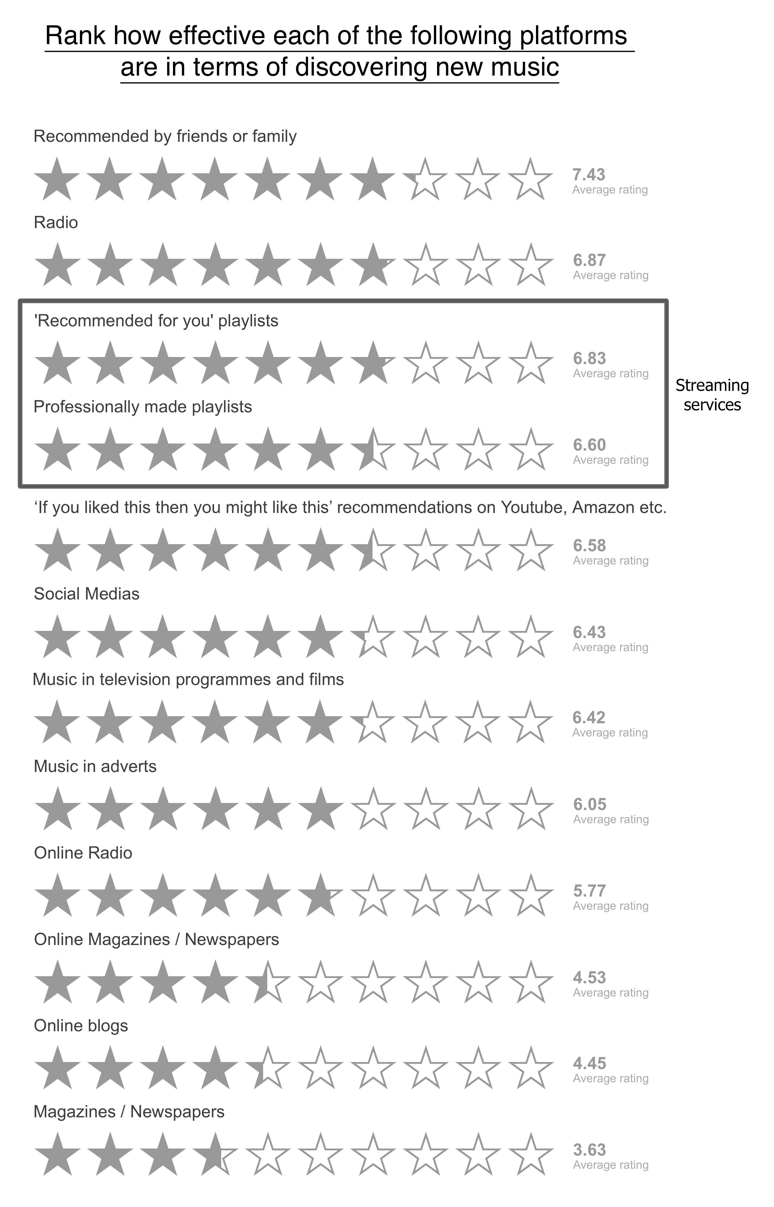

Figure 12. Questionnaire rating scale- How effective are the following discovery platforms? (Author: Lindsay 2016)



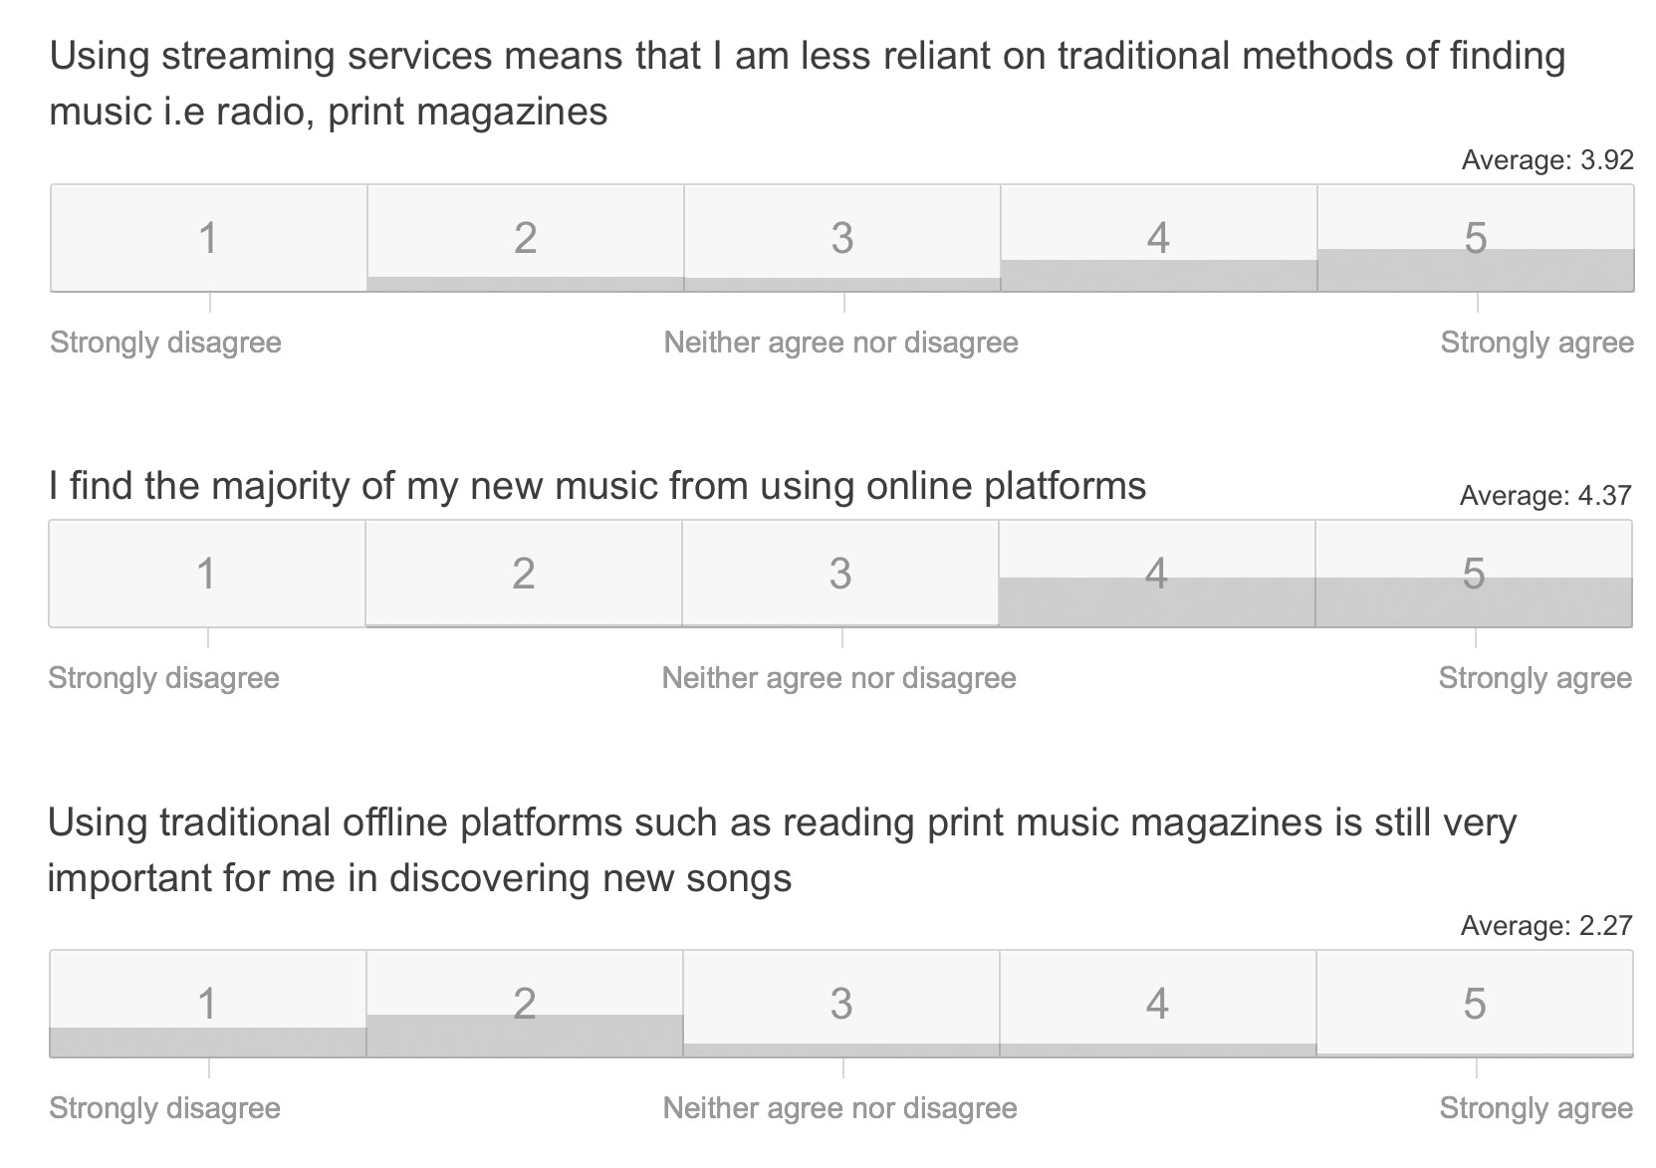

Figure 13. Questionnaire Likert scales- Traditional discovery methods (Author: Lindsay 2016)



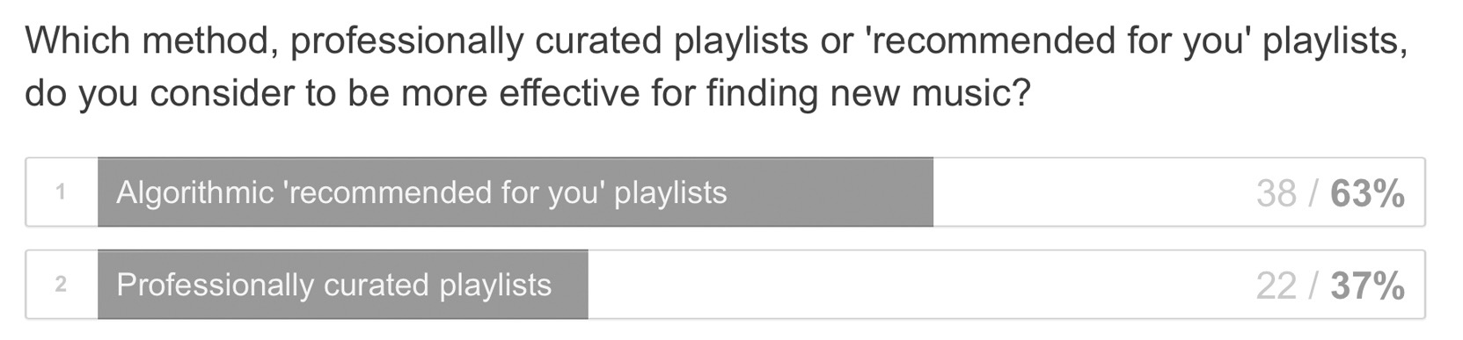

Figure 14. Questionnaire result- Which do you perceive to be a more effective form of curation? (Author: Lindsay 2016)



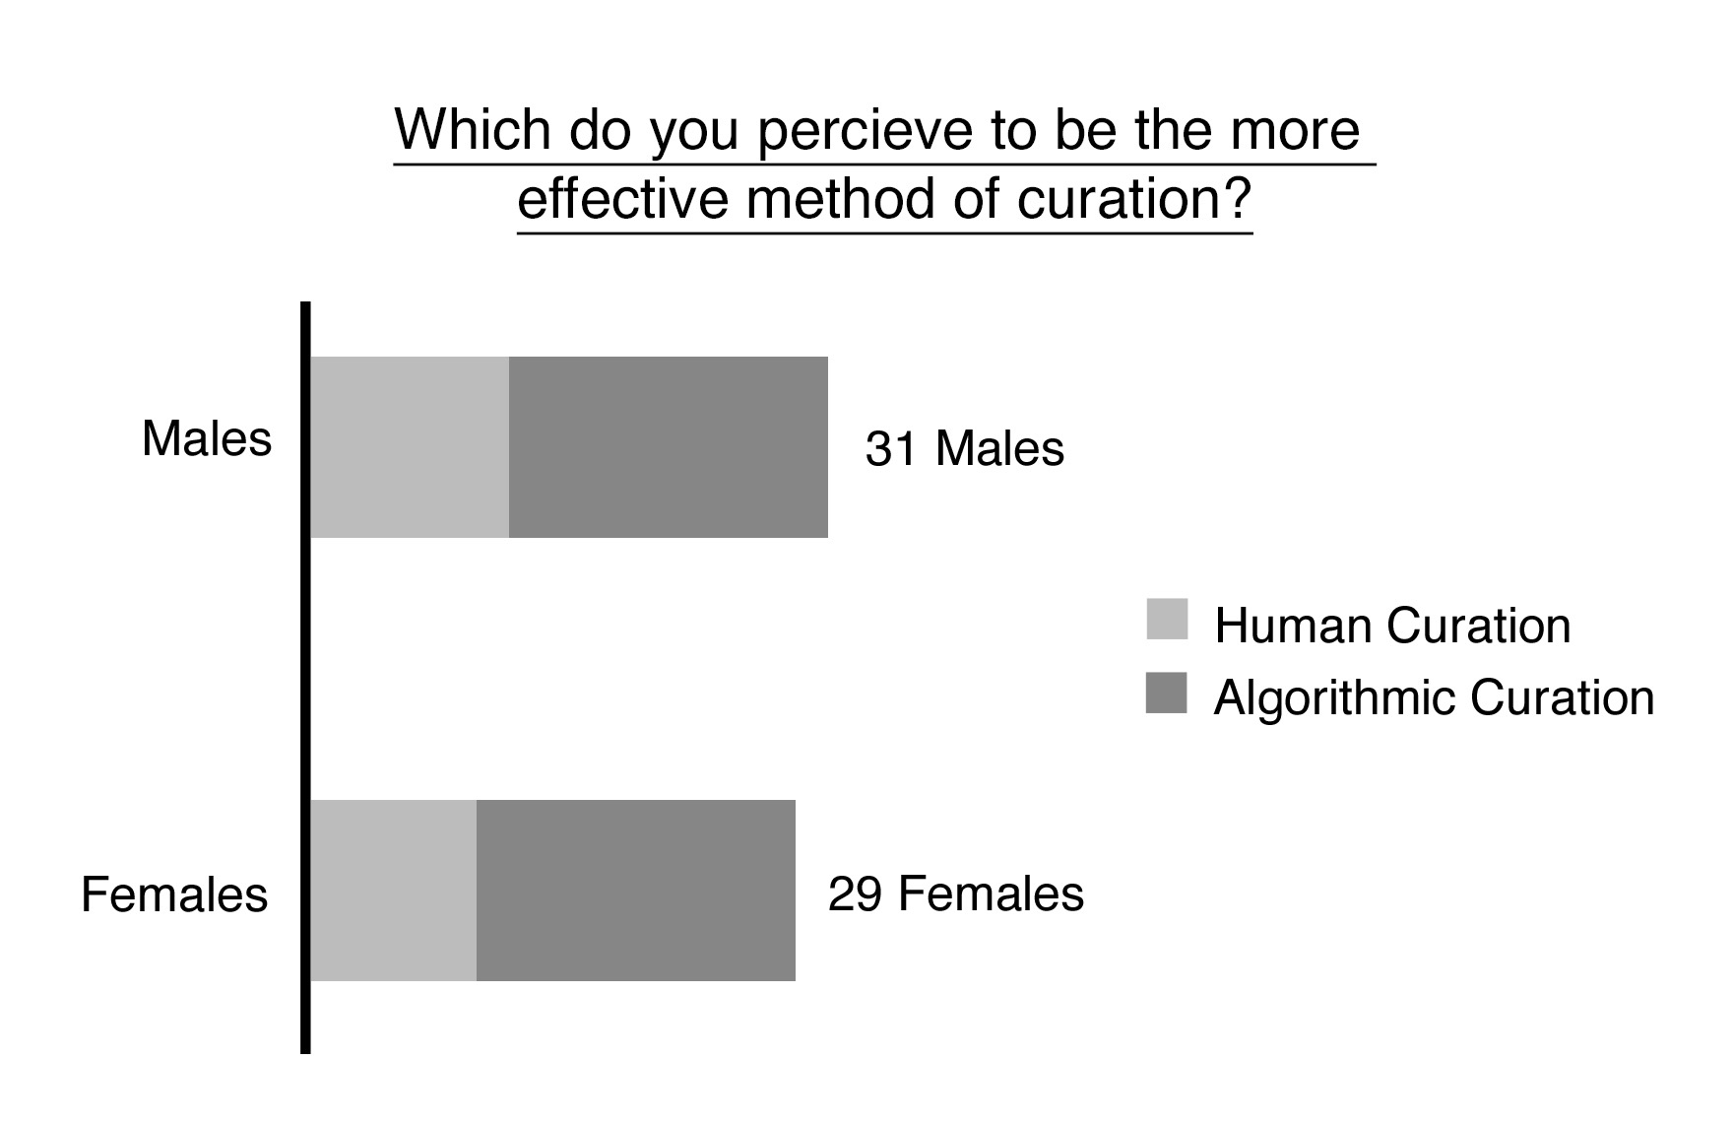

Figure 15. Questionnaire results- Gender effect on curation preference (Author: Lindsay 2016)



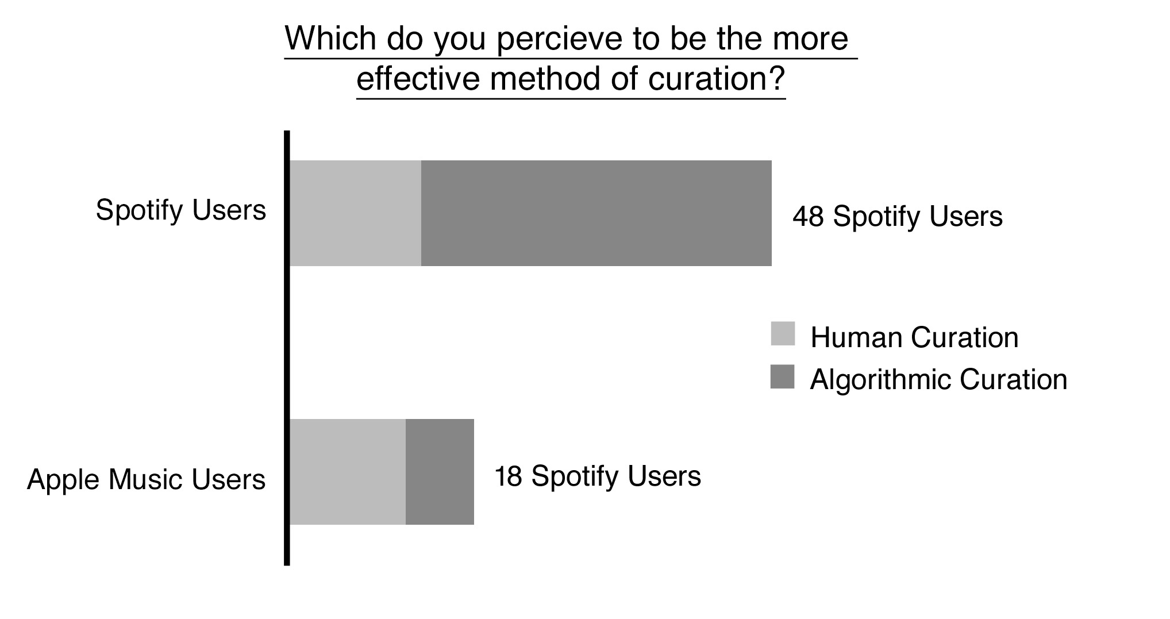

Figure 16. Questionnaire results- Service effect on curation preference (Author: Lindsay 2016)